 | Clock Lodge Options Appraisal  Report Version 1  March 2013 | 

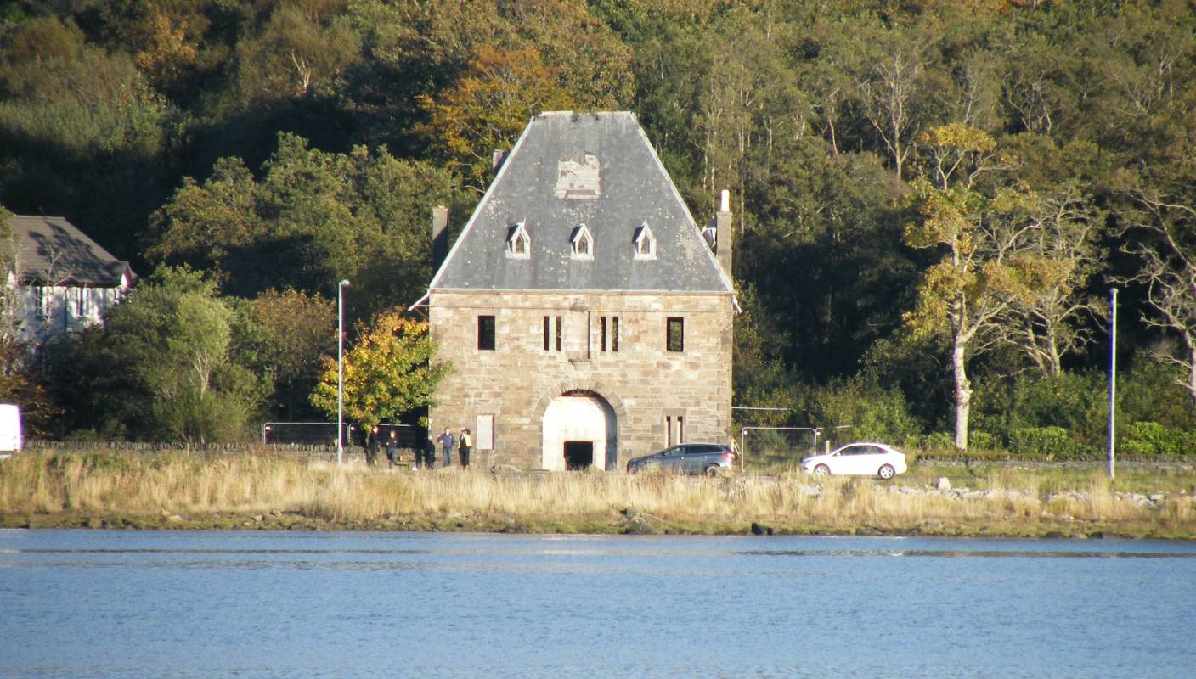

 | 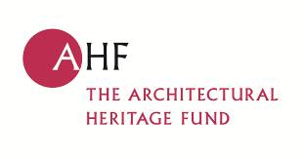 | 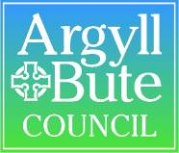 | 

Front pages to include:
- Cover
- SBPT summary page
- Contents
- Exec Summary

Proposed content for the Clock Lodge Options Appraisal

Executive summary & preliminary pages

Content

- Introduction
- Location, history, description and current ownership of building
- Assessment of significance
- Conservation philosophy
- Threats, vulnerabilities and opportunities
- Condition & repairs required
- Context
  - Lochgilphead
  - Physical
  - Other initiatives
  - Public consultation
- Discussion of potential options
- Market analysis
- Preferred Options
  - Sketch schemes – alterations
  - Project costs
  - Values
  - Viability
  - Fundability
  - Development appraisal
- Legal and ownership issues
- Implementation strategy (outline project plan)
- Conclusions

- Introduction

This appraisal has been undertaken by the Lochgilphead Phoenix Project (LPP) in collaboration with Strathclyde Building Preservation Trust (SBPT). The appraisal has been funded by the following organisations:

The Architectural Heritage Fund | £4,000.00
Argyll and Island LEADER | £5,472.50
Argyll and Bute Council | £3,175.50
RIAS Community Project Fund | £1,000.00
Lochgilphead Phoenix Project | £2,000.00

The overall structure of the appraisal is based on the guidance provided by the Architectural Heritage Fund.

LPP and SBPT have procured a team of consultants to assist with this appraisal they are:

Simpson & Brown Architects
Will Rudd Davidson Structural Engineers
Hardies Quantity Surveyors and Valuers

This study will make reference to a number of previous studies of the building including:

- Feasibility Study by Page & Park Architects of 2002 prepared for the Argyll & Bute Building Preservation Trust
- Clock Lodge Kilmory: Review of External Condition and Conservation Significance prepared by Gleeson Historic Buildings Consultants 2009 for Argyll & Bute Council
- Kilmory Home Farm Options Appraisal 2008: Strathclyde Building Preservation Trust for the Kilmory Home Farm Community Group

The Lochgilphead Phoenix Project’s mission statement sates:

The LPP mission is the advancement of Community Development through the regeneration of Lochgilphead by improving the physical, social and economic structure for the benefit of the whole community. The principal improvements to improve the quality of life in the town to be financed initially through grant funding.

- To raise the awareness of the town as a tourist destination in the context of a Scottish wide perspective.
- To increase the attractions available to tourists
- To increase the economic activity of the town

These aims must be at the heart of any options that are considered for the building and its site.

- Location, history, description and current ownership of building

Location

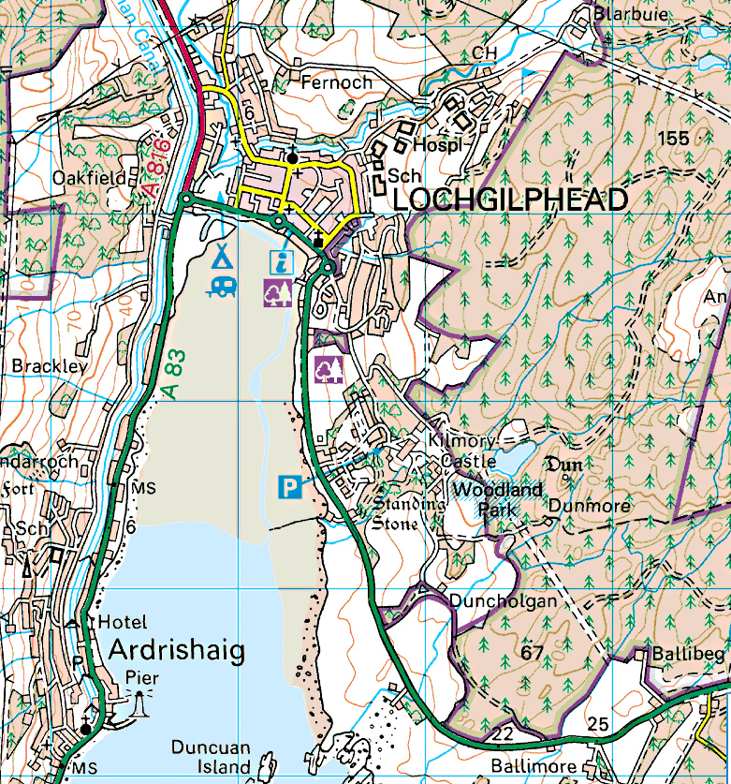 | 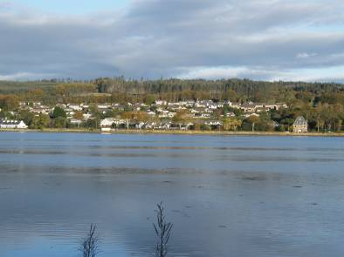 | 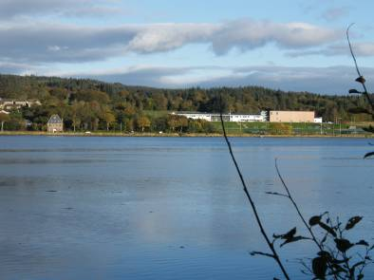
 | 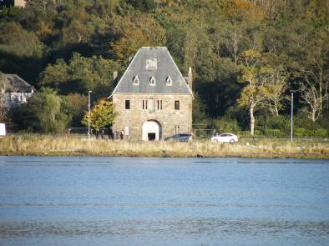 | 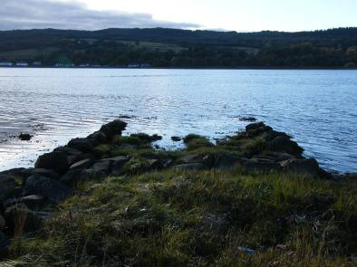
 | 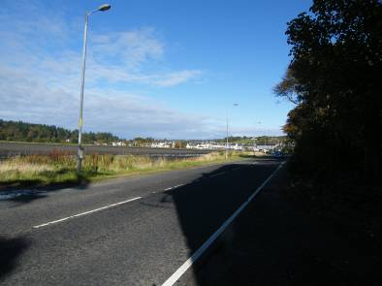 | 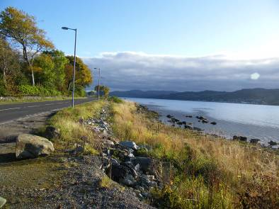
Figure ??: The location of the Clock Lodge photographs Simpson & Brown map © Ordnance Survey

The Clock Lodge is located just to the south of Lochgilphead. Constructed at the end of a causeway that crosses the head of Loch Gilp, it was designed to give access to the Kilmory Estate. It occupies a small, almost triangular site between the A83, the new Lochgilphead joint campus and an estate of houses belonging to Fyne Homes. The site slopes gently towards the Loch but is at the base of a longer slope up to ??? . The site is poorly drained, a situation not helped by the effect of the road as a dam preventing natural drainage into the Loch.
The A83 follows the loch side on its approach to Lochgilphead and this long straight, now contained within the 30mph speed limit, has for a long time been neglected with the result that it is unkempt. The condition of the Clock Lodge doesn’t help the impression that this is an uncared for place and is an unhelpful signal to visitors who could be forgiven for dismissing the town of Lochgilphead even before they arrive.

General description

In spite of its depressed state, the Clock Lodge is an impressive building. It rises from a simple rectangular plan, to two storeys plus attic with a pyramidal roof form, hipped on all sides with a short ridge along the long (north to south) axis. The roof is slated, with zinc hip and ridge details. The east and west pitches are adorned by small, gabled dormers with leaded roofs, heavy timber frames and honeycomb iron glazing bars. To each pitch are the remnants of clock housings again formed in lead. The most complete example is to the south elevation, it gives a good indication of the original form which was a simple, elegant, round topped structure into which the clock face would have been located. Rainwater is conducted via lined stone cornice gutters, which terminate at each corner in lead water shoots supported on cantilevered (wrought) iron brackets extending from the corners of the building. The remaining spouts are again very simple in form without additional adornment.

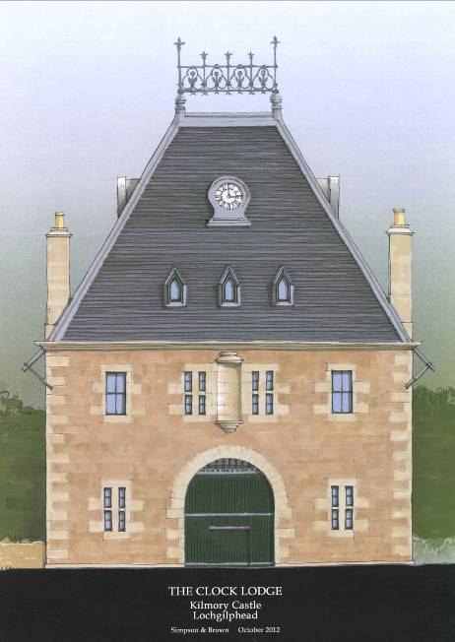

Figure ??: Front / west elevation of Clock Lodge Simpson & Brown

The main elevations to east and west are symmetrically arranged around large, arched openings which indicate that this is indeed a gateway to the estate. Unusual sliding doors close the pend which runs through the building between these arches. To either side are small rooms probably domestic in nature, while the whole first floor forms one large chamber that extends up into the roof taking in what would be the attic storey in one large volume. The pend is roofed with a brick jack arch construction, supported on substantial iron beams. The windows to the first floor are timber framed, a pair of heavy mullioned lights to either side of the west elevation flanked by simple sash and case windows. To the east elevation a central formation containing the honeycomb glazing is flanked by two smaller casements.

The structure is of random masonry with dressed stone to the chimney stacks at the north and south. These seem to have been raised at some point, with a flat (opc?) render finish which is ashlar lined. The raising of the stacks has obscured the clock housings to these elevations. The corners of the building have dressed quoins flush with the main masonry, while arched openings are formed from segmental vousoirs. The mass masonry is particularly random, with a mixture of stone types, varied bedding pattern with a range of pinning and infilling. Some stones are dressed but incorporated into the random rubble and there is an impression that much of the stone may have come from other structures. Above the front (west) arch is an empty, semi-circular niche, capped with a simple inverted ogee dome with a round cushion cap. The plinth is simpler still, formed from an inverted cavetto moulding on a reverse ogee bracket supported by a cushion base.

It is worth noting that the historical analysis of the Home Farm contained in the 2008 appraisal, also suggested the re-use of stone in that building. This raises the question of where the stone came from and how many elements in both the Clock Lodge and Home farm might have come from an earlier building on the estate. Could these buildings contain remnants of the earlier Kilmory House?

The windows vary in their pattern without any apparent logic to the arrangement. Some have heavy slab mullions perhaps providing additional security, while some are traditional, domestic scale sash and case windows. The east elevation, first floor window formation is wide with more delicate, moulded stone mullions housing fixed, honeycomb lights.

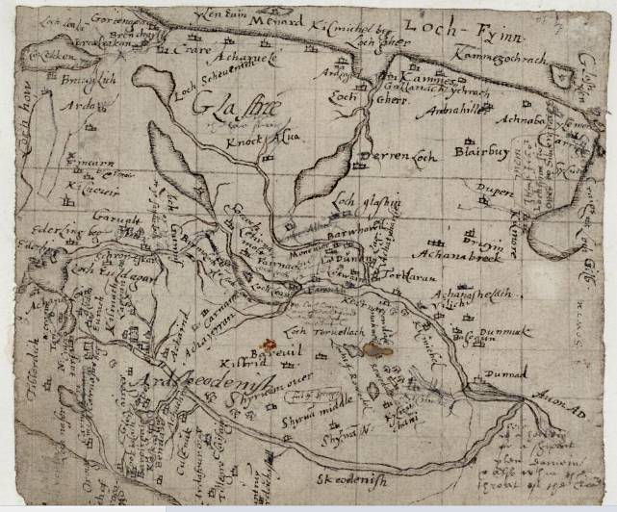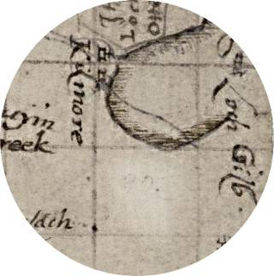

Figure??: Pont’s survey of the Crinan Canal 1583-1614 illustrating Loch Fyne & Loch Gilp and naming Kilmory on the Loch side Reproduced by permission of the National Library of Scotland

Michael Davis wrote a comprehensive assessment of the architectural, historical and social significance of the Clock Lodge which is included in the 2002 Page & Park study. Further contextual information was provided for the 2008 Kilmory Home Farm Options Appraisal produced by Davis for SBPT in collaboration with the Kilmory Home Farm Community Project. Both these documents are held by SBPT and the following notes are therefore presented only as a brief summary of the history of this building and the Kilmory Estate.

An early reference in a charter, apparently dating from the 1230’s, granted the “penny land of Kilmory which lies above Loch Gilp with the Chapel of St Mary built on said land” to Paisley Abbey. In 1558, the Abbot of Paisley granted the lands to John Lamont of Inneryne, and by 1575 they had come into the possession of Donald Campbell of Kilmory. By the mid 18th century, the Campbell family were styled ‘the Campbells of Fish River and Kilmory’, Fish River being their estates in Jamaica powered, as with so many such estates at that time by slave labour. A series of letters and papers published by Marion Campbell in 2004, illustrates the internal discussions about who would live at Kilmory and how the estate would be developed. John Campbell of Orange Bay (another Jamaican property) was to take on the estate and he talks in correspondence of the various plans he has, from building a small mansion “a neat, clever house” to locating an orchard of about 2 acres to be planted with cherries, plums, apples, pears, walnuts, quinces, currents and gooseberries. Davis comments that this is possibly the forerunner of the walled garden still located to the south of the Castle. John Campbell never did live at Kilmory, and the estate eventually came into the possession of Sir John Powlett Orde (1803-78) in 1828, after his marriage to Eliza the daughter of Peter Campbell, the last Campbell owner of the property.

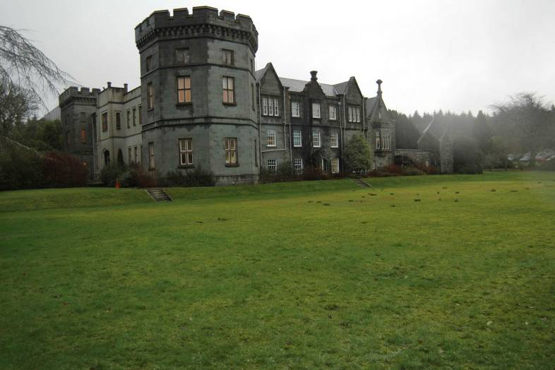

Figure ??: Kilmory Castle from the north west SBPT

The Clock Lodge is one of a series of major alterations and upgrades begun by Orde almost as soon as he took possession of Kilmory. This involved the remodelling of the house to create the widely admired Castle, construction of a new Home Farm and service buildings and development the agricultural potential of the policies. It appears from contemporary reports, that Powlett Orde was intimately involved in the detail of these improvements from the design of buildings to the choice of cattle on the estate. His love of carriage racing influenced the layout of policy roads, leading to the incorporation of sweeping corners, slip roads and roundabouts. The policies meanwhile were improved, a process that involved the removal of a number of farmsteads, crofts and other houses. The main road, which cut through the estate to the east of Kilmory House, was moved to the loch side, the current route of the A83.
The Orde’s also developed the garden. This work included the evolution of the walled garden and the planting of may rare rhododendrons, a feature of the garden even today and it appears that they may have been assisted in this endeavour by Sir William Hook. Orde was also in control inside his new house, commissioning furniture and ensuring that it was both tasteful and modern. The entrance to the Castle allowed carriages to come through a giant front door into a pend passing through the heart of the house where passengers alighted. This area is now the Argyll & Bute Council reception.

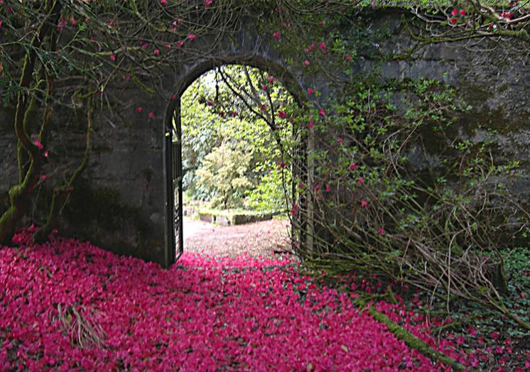

Figure ??: The entrance to the walled garden SBPT
The key story in the history of the Clock Lodge relates that having injured or whipped a child whilst driving his coach through Lochgilphead, Orde’s coach was stoned and he vowed never to enter Lochgilphead again. His solution was to by-pass the village by constructing a causeway across the head of Loch Gilp and at the eastern end he built the Clock Lodge to “defend this new entrance to his land”. The causeway in turn, is said to have enraged the local fishermen whose operations were apparently impaired upon by this obstacle. Alternative theories for the construction of the causeway include the possibility that it was intended as a breakwater to help trap mud and gravel to stabilise the Ebb, or that the causeway and the Lodge were built to welcome and impress Queen Victoria and Prince Albert on their on their visit to the Crinan Canal in 1847.

The veracity of any of these stories are is unclear, however it is easy to understand the appeal for the speed loving Orde of dashing over a causeway covered with an inch or two of water. How much more exhilarating, if this excitement was followed by a clattering passage through the formidable Clock Lodge and on into the sublime landscape of Kilmory. And if this wasn’t enough this sensational passage culminated in the fantastic entrance to the Castle and its exquisitely designed interiors.

It is this love of speed and almost child like exuberance perhaps, which is the basis for the (as yet unproved) assertion that Orde was an influence on Kenneth Grahame’s characterisation of Mr Toad in the “Wind in the Willows”. Grahame spent his early life in Ardrishaig and Lochgilphead, his father being the Sheriff of Argyll. After his mother’s death in 1864 however, he moved with his sister and brothers to his grandmother’s house Berkshire where he spent most of the rest of his childhood.

Orde’s scientific bent was demonstrated by the design of an award winning field gate, he is also said to have had a specific interest in automatically opening gates. These apparently, operated as an approaching carriage crossed a metal pressure plate in the ground. Gates with an easy open pulley system remain in the Castle grounds today. We form a picture of Orde then and as Davis says the “provision of a highly unusual lodge or gatehouse, pierced by a pend sealed by sliding doors at either end and directly facing and serving an innovative if eccentric causeway”^{i} is not that surprising.

No original plans have been found for the Clock Lodge and its architect is unknown although it may have been designed with the input of Joseph Gordon Davis, a London builder. Joseph Davis assisted Powlett Orde in the redevelopment of Kilmory House and the Home Farm. He undertook some work for the Duke of Argyll, designed Kilmartin Church and was certainly involved in the building if not the design of the hotel now known as the Grey Gull in Ardrishaig. Michael Davis believes that Powlett Orde and Joseph Davis had a fruitful collaboration and that Orde may have played a major role in some of the design work now attributed to Davis the builder.

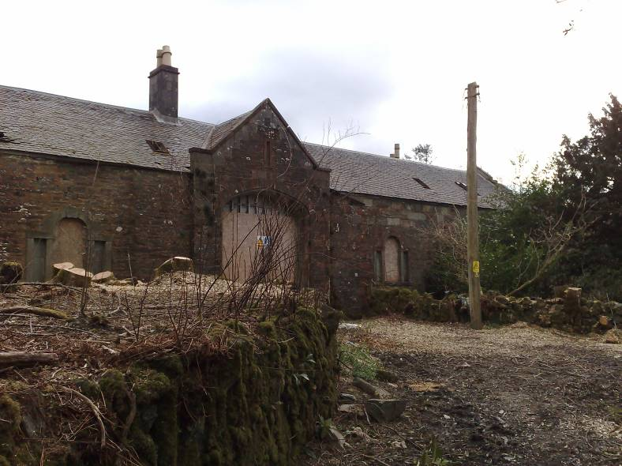

Figure ??: The entrance to Kilmory Home Farm SBPT

There were 3 lodges and 4 carriage entrances to the Kilmory Estate. The Lingerton Lodge is to the south-east some way from the Castle, the Red Lodge closer by to the south and the North or Clock Lodge at the Lochgilphead end of the estate. The White Gates entrance which passed directly into the village (onto what is now Cossack Street) had no lodge. Lingerton and the Red Lodge are modest buildings while the Clock Lodge is altogether more of a statement. The Clock Lodge is clearly linked with the causeway and the 1867 OS survey illustrates the woodland planting and drive from the Lodge into the road network of the estate and onto the Castle. The drive to the east of the Lodge was identified and photographed in the 2002 study. The exact date of construction of the causeway is not clear but the Davis asserts that there is sufficient evidence to place it between 1844 and 1867 when the first Ordnance Survey was undertaken while the 1861 census refers to only 2 lodges on the estate, it is not clear whether the North Lodge was one of these. The first reference to the building as the Clock Lodge is in the 1887 rating description.

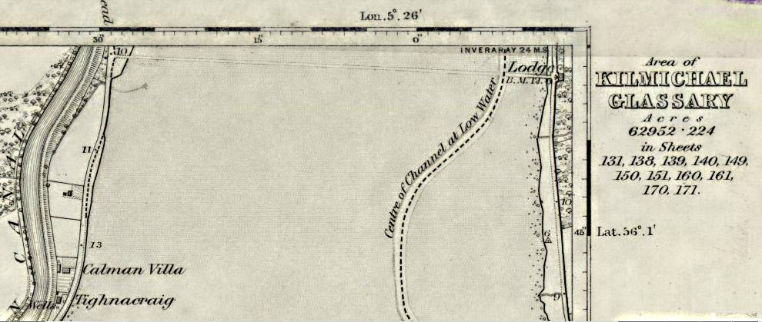

Figure??: Section of the 1867 OS the Clock Lodge and causeway
are visible to the top of the map Reproduced by permission of the National Library of Scotland

The accommodation provided by the Lodge is described by Davis as follows.
“Internally, the Lodge contained a self contained arrangement of two ground-floor rooms (each with a sleeping platform and a fireplace) on one side of the pend, with a further two smaller rooms (each with a fireplace) on each side of the stair on the other side of the pend. In 1885 there was only one resident, a lady – “Widow MacTavish” - who may have possibly have been resident caretaker. What the ground floor rooms were really used for is not wholly clear, although the likelihood is that the sleeping platforms are original, making residential use likely. Arching of industrial specification would have allowed the upper chamber to be suitable for accommodating heavy machinery or large numbers of people. A number of possibilities for use of this upper floor are suggested, but these suggestions are based on no firm evidence.”^{i}

There is a carriage step in the pend and this suggests an intention for visitors to alight here. So it is possible that one use of the upper floor was as a banqueting or picnicking hall. Other uses suggested include a community use, for the annual Tenants’ Ball perhaps or as an institute. There is also speculation that the room might have been a detached library or study for Orde himself or a workshop or laboratory where he indulged his scientific interests. Of course the clocks on the Lodge would have provided a very overt (and perhaps unwelcome) method of timekeeping for his estate workers and the local community, while what Davis refers to as the “symbolic defence” of the estate by the Lodge, was perhaps a representation of the ongoing feud between Orde and the people of the village.

In his 2002 summary, Davis identifies a number of innovative features of the lodge which again do not appear entirely surprising when we think of Orde as a man interested in science and engineering. Of these innovations, perhaps the most interesting is the use of ‘pocket’ sliding doors across the pend. Another local example of this unusual arrangement is found at Porltalloch and is believed to have been designed by Charles McKntosh an expert in garden technology around the mid 19th century. The design required a double thickness wall to be constructed and in effect two windows one to each wall leaf in the front and rear walls, thus the door slides between the separate wall and window structures.

Today, little of the interior decoration or fitting out of the Lodge survives but the raised bed platforms on the ground floor may well be original features. The ground floor rooms all incorporate fireplaces, while the main chamber above includes a large fireplace to the north wall, while the roof structure (largely timber but with iron ties) is expressed. The chamber is thus, a double height space lit both by windows at about 3m above floor level and by dormers set much higher in the roof slopes. The upper storey windows incorporate iron glazing bars, possibly locally made or manufactured elsewhere. The main chamber is finished in pine match boarding with ‘V’ cut joints. There is no evidence of a finish to this boarding. Above the boarding, is lath and plaster extending into the roof space as a coved ceiling. The plaster to the walls exhibits bits of wallpaper, the date of this is not known.

Architecturally, the Lodge takes its references from northern Europe, the steeply sloping roof and configuration of the clock cowels being perhaps German or French in origin. This is though, a plain building relying on its overall form rather than prolific detailing to impress. But the details that do exist, the high dormers, the clocks and the unusual fenestration all contribute to the marriage of technology with historical style in a way that is typical of Victorian architecture and the man behind its construction. The Lodge also incorporates a structural vault to the pend and unless this was designed to support a very heavy function above its engineering could be considered excessive and more suited to an industrial building. Two lost or very damaged features of the Lodge that require further research as essential parts of the composition are the clocks and the water spouts fitted in place of traditional downpipes. Whether the latter could be reinstated without causing a deluge onto the A83 is questionable but the refitting of clocks to the Lodge must be an ambition of any conservation project.

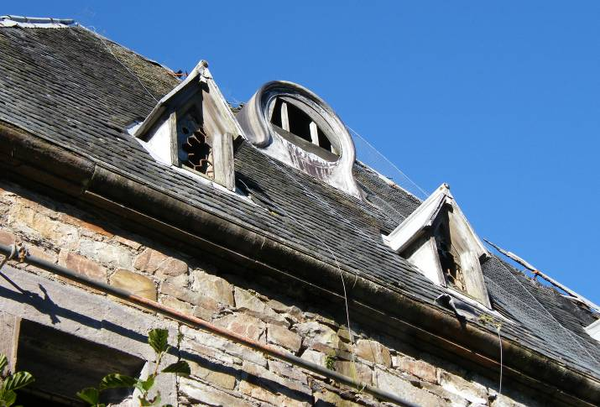

Figure??: The East roof pitch with clock housing and dormers Simpson
& Brown Architects

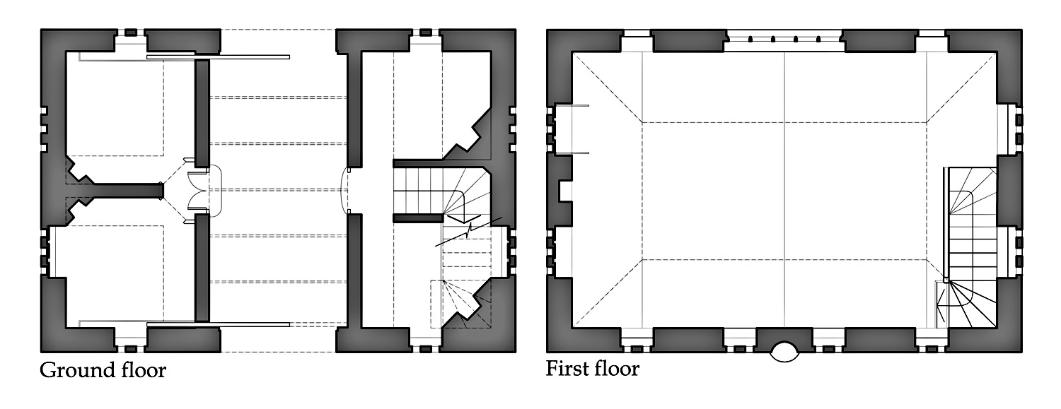
Figure ??: Floor Plans of the Clock Lodge Simpson & Brown Architects

- Assessment of significance

This assessment is written on the basis of the concept of cultural significance defined by the Burra charter (current ed 2009). There are other valid methodologies but the Burra Charter is the most widely adopted statement of conservation best practice and is therefore considered appropriate to this project. Comments in italics below are direct quotes or terms used in the Charter.

Cultural Significance is defined in the Burra Charter as the “aesthetic, historic, scientific or social value for past, present and future generations” of a place. The Charter goes on to say that “cultural significance is a concept which helps in estimating the value of places. The places that are likely to be of significance are those which help an understanding of the past or enrich the present, and which will be of value to future generations.” A place may not demonstrate significance in all these areas and in the case of the Clock Lodge, it is considered that significance is particularly exhibited in three:

- Aesthetic including architectural
- Historical
- Social

Aesthetic significance

“Aesthetic value includes aspects of sensory perception for which criteria can and should be stated. Such criteria may include consideration of the form, scale, colour, texture and material of the fabric…..” Beyond this statement, the importance of understanding how this building informs our appreciation of architectural development in a local, regional and national context is essential to an objective assessment of its significance. Thus the following assessment is derived, with particular reference to the following criteria:

- Architectural style, form and scale
- Building material, technology and functional detailing
- Interior layout

The Clock Lodge is a highly unusual building and it is a struggle to characterise its architectural style succinctly. The Listing Description defines it as “German” and this seems reasonable although its architectural influences may be drawn more broadly from northern Europe. The principle aesthetic of the building is however, derives from its function as a gate house. The arch fronted, gated pend is the key feature of the main elevations providing at least symbolically, a secure entrance to the Kilmory Estate. Looking beyond this very obvious feature however, the detail of the fenestration, the inclusion of a niche (possibly never occupied) and the extravagance of the roof form combine to provide a building which makes a real statement now and must have been extraordinarily impressive when it was built in the early 19th century. The floor area of the building is a modest ??m² but it is still oversized in comparison to the other lodges on the estate and dominates its setting. The purpose of choosing this audacious aesthetic treatment is not certain but it is reasonable to assume that it was to provide an impression of the owner of the Kilmory Estate as a man of wealth and sophistication but also as somebody not to be messed with. Arches were a popular form for gatehouses, as with William Kent’s first lodge at Holkham Hall and again at the Oxford Gate at Stowe. Unlike the Clock Lodge however, the architectural style of these buildings gives a taster of that employed in the big house itself.

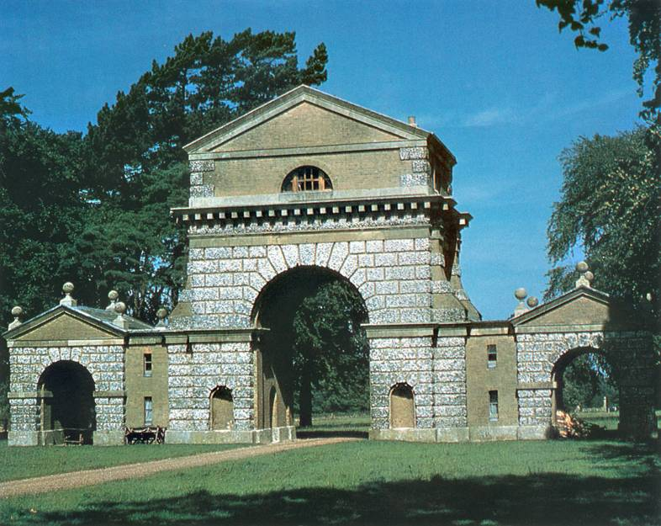

Figure ??: Kent’s Holkham Hall Triumphal Arch inspired lodge SBPT

Orde (and Davis) would certainly have been aware of such high end examples of the gate lodge but their Germanic interpretation is perhaps unique. The incorporation of a viewing level is again a common feature and where better than at the Clock Lodge with its spectacular views across Loch Gilp. The Clock Lodge is a late example of this monumental lodge type however. Goodwin’s “Domestic Architecture” was published in 1833 and extolled both the benefits of proper accommodation in the lodge but also of opening the gate up to provide views into the park. Proper housing for the gate keeper and a less ostentatious appearance is clear from examples by architects such as David Bryce at Broadstone House in Port Glasgow and at Luscar House Fife.

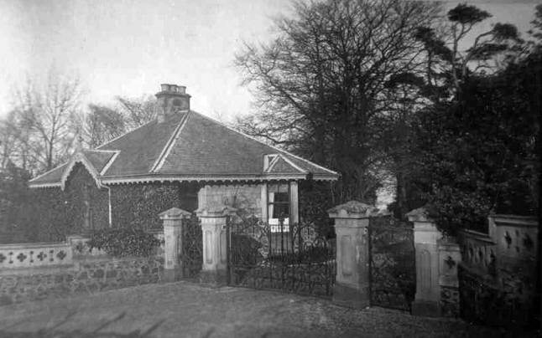

Figure ??: Bryce’s comfortable lodge at Broadstone
http://www.portglasgow4u.co.uk/Birkmyre_Connection/Broadstone_History.html

The Clock Lodge is not built of any particularly extravagant materials, rubble masonry walls with dressed details and a slate covered roof are common. The inclusion of stones which appear to have been harvested from a previous building is interesting however and ties in with the possibility of the same practice elsewhere on the estate and in particular at the Home Farm. The extent of this practice in this building has not been confirmed (and may never be) but further analysis of for example, the window formations during any future project would be of value.

The functional detailing of the Lodge is both intriguing and unusual. The idiosyncrasies begins with the clocks after which the building is named. It appears that four faces may have been included although again, this is to be confirmed by further research. In the end however, even if only one clock face was incorporated into the building, it would have been a very prominent and practical feature. The design of the cowls for the clock faces, is reminiscent of something much smaller perhaps a carriage clock or a watch housing. They are almost Rococo in character and designed to be seen from some distance and presumably through the chiming of the clock, to remind everybody of where they should be and when.

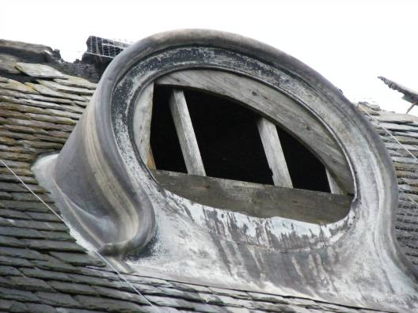 | 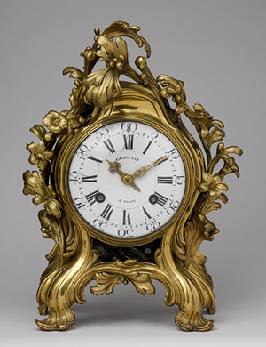

Figure ??: The clock housing, pinched at its base reminiscent of a
mantle clock Simpson & Brown Architects & www.metmuseum.org

Moving down the roof, the high level dormers which provide top lighting to the first floor chamber in the building, are again unusual. Their steep sloping roofs and heavy moulded timber surrounds are fanciful and more cottage ornée than classical in derivation. The incorporation of cast iron grill glazing bars in a honeycomb pattern accentuates the almost fairy tail character of these features. And once again these details are prominent, three to each of the principle elevations.

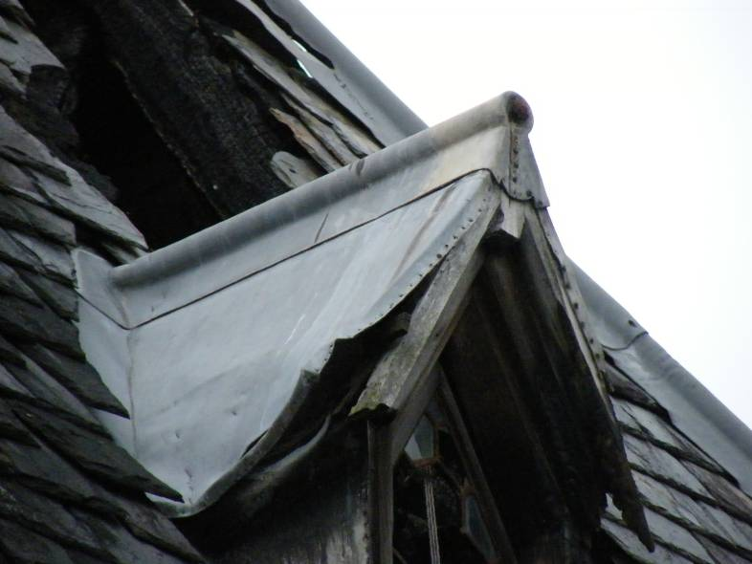

Figure ??: Example of dormer window Simpson & Brown Architects

The next functional feature of unusual form is the rainwater disposal, no downpipes here rather the system conducts water to lead spouts that would shoot the not inconsiderable run off from the large roof some distance were they in operation. Below roof level is the enigmatic niche, designed to be occupied or as a reference to historic ruins robbed of their statuary? And why is the window pattern to the ground floor not universal? Of the four openings on the principle elevations, three comprise a double, slim casement with a heavy central, stone mullion. The fourth to the front (west) is a far more conventional rectangular light containing a simple sash.

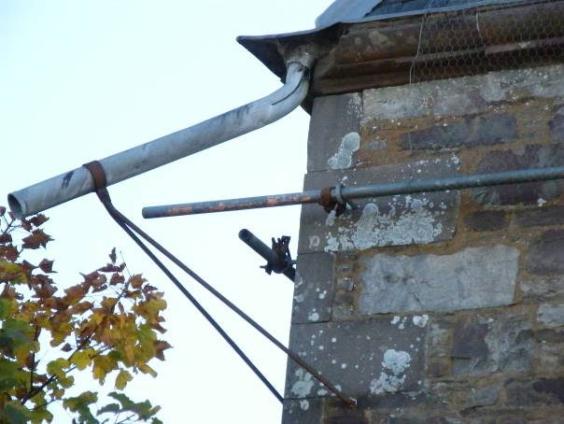 | 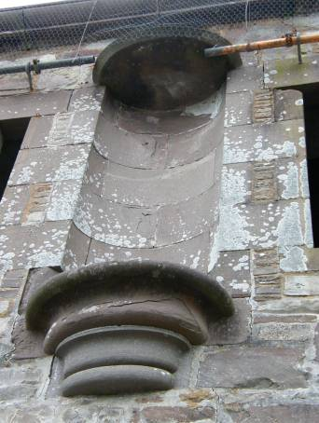

Figure ??: Water spout and niche Simpson & Brown Architects

The final quirk of the building is arguably the most interesting, the large sliding doors to the pend. These as noted above, are designed to slide into a slot between inner and outer wall leaves. This necessitates a doubling of the windows on the principle elevations one to each leaf.
Internally, the Clock Lodge is similar to many earlier and grander lodges in that the living accommodation is considerably compromised to allow the external form to transmit its intended impressions of wealth, modernity and sophistication. Crammed into the ground floor on either side of the pend are three main rooms, two contain what appear to be original bed platforms and all have a fireplace. The loss of light when the sliding doors were open and the unheated pend must have made occupation of this space pretty uncomfortable.

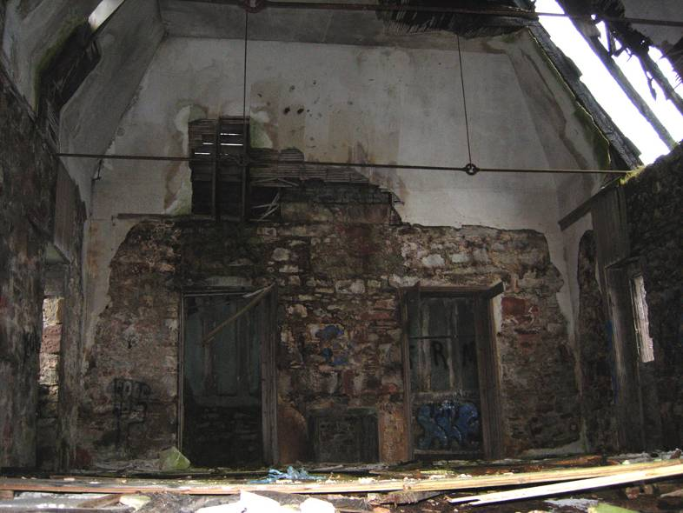

Figure ??: The first floor room Simpson & Brown Architects

Above, the first floor galleried space is one of the key features of the building. With its panoramic views over Loch Gilp to Ardrishaig and the Kityre Peninsula beyond, this well lit room must have been a tremendous space. We don’t know what it was used for and one apparent draw back to its occupation, is that there appears only to be one small fireplace. Once again, this must have been a cold room perhaps only for summer occupation. The roof itself is a fine piece of 19th century engineering, incorporating a primary timber structure with wrought iron ties it exemplifies the growing understanding of the structural characteristics of iron and its uses.

In summary then, the Clock Lodge is a highly unusual building designed to impress. It combines architectural styling not common in the West Highlands with individual detailing to create an exceptional piece of built heritage. Set alone on the Loch side it is prominent, monumental and can rightly be said to “enrich the present”. Its substantial contribution to the architectural record of the area means that it will also surely “be of value to future generations”.

Historical significance

“Historic value encompasses the history of aesthetics, science and society…. A place may have historic value because it has influenced or has been influenced by, an historic figure, event, phase or activity. It may also have historic value as the site of an important event. For any given place the significance with be greater where evidence of the association or event survives in situ, or where the settings are substantially intact, than where it has been changed or evidence does not survive. However, some events or associations may be so important that the place retains significance regardless of subsequent treatment.”
The Clock Lodge is not associated with any single major historical event. It is however, a reminder of a phase of rapid change in the history of Argyll when the way land was owned and worked was comprehensively transformed. It is a remnant of a programme of advances instigated on a minor estate by a progressive owner, from the nouveau riche rather than the traditional aristocracy. It links through this owner to the international trade on which Scotland and the wider UK built wealth from the late 18th century onward. It is the creation of an owner who would have worked for a living, taking a hands on part in managing his business from Kilmory to Glasgow and beyond. And this hands on approach extended to the management of his estate. Orde was instrumental in the improvements to the farming techniques at Kilmory, which involved consolidation of the land under one management through the displacement of tenants. He introduced new stock and experimented to improve the blood line, he constructed a modern Home Farm with up to date facilities for his horses and workers. He remodelled his house, laid out the garden with input from the prominent horticulturalist William Hook and delighted in science and engineering. His exuberance extended to curragh racing and he designed the functional routes round the policies to provide an extensive racing track. And he built the causeway and the Lodge to demonstrate his cleverness and inventiveness and by inserting the clock into it, he made certain that all around were regularly reminded of his position in local society.

In summary, the Clock Lodge is an important and unusual remnant of 19th century estate improvement in the West of Scotland. It’s incorporation of European architectural styling demonstrates the fashion of the time for eclectic architectural styling, its form and function are indications of the extravagant character of its owner and originator. Its location at the gateway to Lochgilphead has placed it in the consciousness of generations of local people and the current community is keen to ensure that it continues to influence the lives of future generations.

Social significance

“Social value embraces the qualities for which a place has become a focus of spiritual, political, national or other cultural sentiment to a majority or minority group.”

The social significance of the Clock Lodge is very closely allied to its historical value but it is amplified by the view of the community in Lochgilphead today that this important link with the history of the town should not be lost and indeed that it should be conserved, made available to them and celebrated. The Kilmory Estate has been and remains an important part of the social make up of Lochgilphead. Until the mid 20th century, it would have been the home of the local aristocracy, a major employer and a major influence on the way society in the are was conducted. Latterly, the adoption of the Castle as the Local Authority headquarters has perpetuated that influence both economically and socially. The Clock Lodge is a very visible element of the Estate and while it is redundant and derelict it still speaks of the authority and confidence that made the Kilmory Estate and so many others like it so influential in our history.

Historically, the Clock Lodge speaks of a time when land owners reorganised not only their land but the lives of the people living there. They removed them from their traditional land, they employed them, they ordered their lives and the imposing scale and architecture of the Lodge is designed to provide a clear understanding of who is in charge here. And this is not enough for Orde, the insertion of a clock in the building with multiple faces, dictates to his workers. The Estate more broadly and the Clock Lodge more specifically are intrusions on their lives and freedom. The importance placed on the conservation of the Clock Lodge by the present community in Lochgilphead, demonstrates the continuing social importance of this building.

Grading the significance of the Clock Lodge

The grading of the significance of various elements of a building has become common practice. It can be dangerous because often the record provided by a whole composition can be damaged if an element that is considered of less importance is altered. With that caveat in mind, the following photographs identify areas of the Clock Lodge that can be graded in relation to their contribution to the significance of the overall building. Levels of grading are:

Outstanding
Considerable
Moderate
Neutral
Negative

Elements of outstanding significance are generally those that are of international importance, or elements that demonstrate particularly fine or unaltered examples of a particular style, period or type of building.

It is not considered that the Clock Lodge contains any elements that are of international significance

Elements of considerable significance are generally those that are of regional or national importance or are a good example of a particular period, type or style with a high degree of intact original fabric that contributes to the overall importance of the building or site. The Clock Lodge is a highly unusual example of the lodge type, late in its monumentality and perhaps unique in Scotland for its incorporation of Germanic or northern European historical styling. The building maintains a considerable amount of its original fabric both in its materials and in the unaltered state of its interior and fenestration. Of considerable significance is the detailing of the Clock Lodge, which are both quirky and somewhat disparate. That the whole comes together as a satisfactory composition is quite surprising.

The category B listed status of the Clock Lodge indicates its regional significance and it is considered that this appropriate. The building contributes considerably to the record of lodge buildings and more widely, estate buildings in Argyll. Without seeking to overplay its national importance, it is also considered that the Clock Lodge is a fine and unusual example of estate architecture that makes a significant contribution to the national record of this important building type.

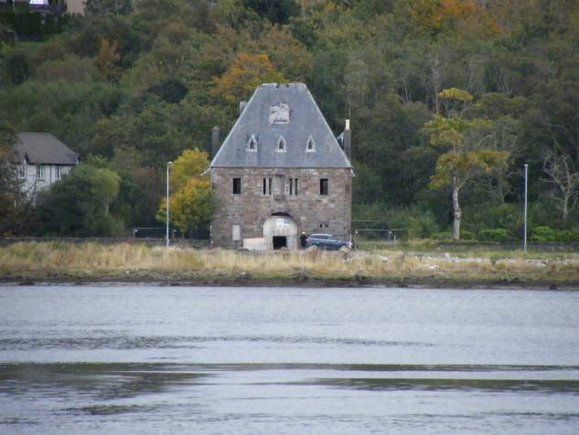

Figure ??: Photographs illustrating details of the Clock Lodge that
Are considered of considerable significance Simpson & Brown Architects
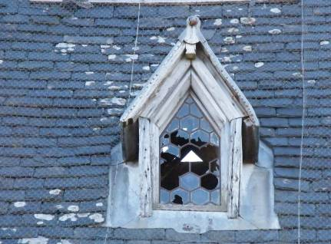 | 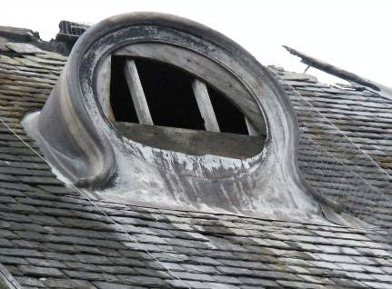
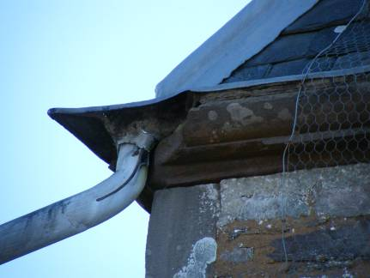 | 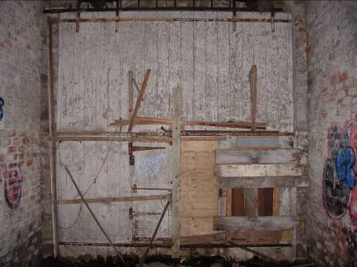
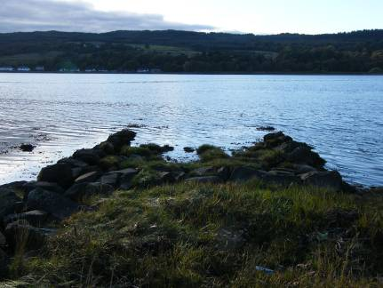 | 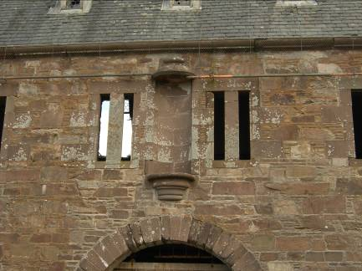

Details include: dormers, clocks, water spouts, the sliding pocket doors, the relationship with the causeway and the overall composition of disparate styles and details.

Elements of moderate significance include those that contribute to but are not key to the importance of the building or site overall.

The Clock Lodge is a good example of its genre but it mirrors others in some respects. Elements of moderate significance are considered to include its general layout about a central arch or in this case pend and its consequent compromised accommodation. The retention of vestages of the original fixtures and fittings to these spaces such as the bed platforms is considered of moderate significance.

The utilisation of almost industrial techniques to ground floor ceiling and support the upper floor is also considered of moderate significance.

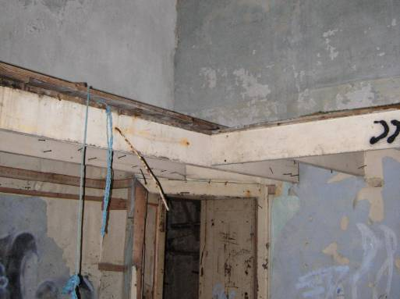 | 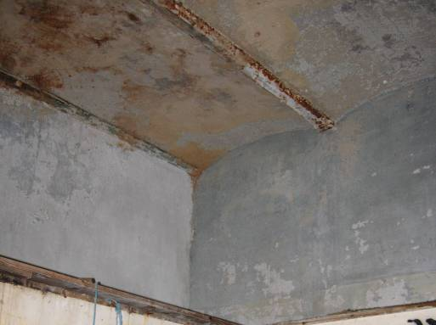

Figure ??: The bed platforms & engineered ceiling structure

Elements of neutral significance are those that neither contribute to nor detract from the overall importance of the building or site.

It is not considered that the Clock Lodge contains any elements of neutral significance.
Elements of negative significance are those that detract from the overall significance of the building or site.

The setting of the Clock Lodge has been considerably compromised by first the encroachment of modern housing to the north and later by the Joint Campus development to the south. In particular this has had an impact on the views of the Lodge from the west side of the Loch and the Town Green. The loss of function through the redundancy of the drive through the Lodge to the Castle has also damaged the completeness of the building’s significance. Alterations to the chimney stacks are unfortunate, in particular because they obscure the view of the north and south clock faces (or windows?). Perhaps the most telling loss however, has been the removal of the clock.

There is an inevitability about the development of Orde’s relocated main road but the proximity of the A83 to the front of the building must be considered a negative element as is the impact that the raising of the road has had on the site of the Lodge.

Overall however, the condition of the building must be considered the most negative element of the building at present.

Summary of significance

Overall, it seems reasonable to state that the Clock Lodge is of moderate to considerable significance in accordance with its category B listed status. This building is hugely importance locally and has an important part to play in the overall historical record of Scotland and the United Kingdom.

Housing development extends behind the building and is damaging to the wooded setting of the Clock Lodge | The Lochgilphead Joint Campus dominates the view from the Ardrishaig side of Loch Gilp

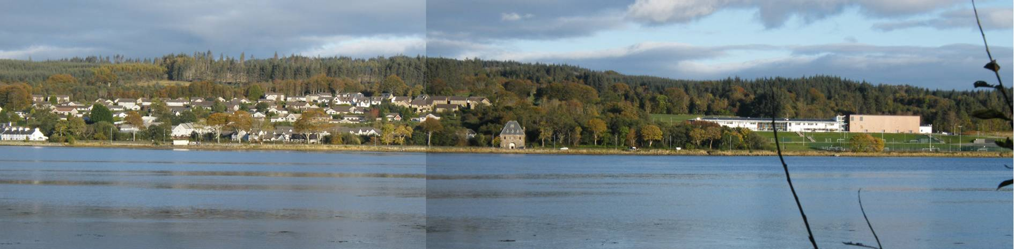

Figure??: The setting of the Clock Lodge compromised by recent development Simpson & Brown Architects

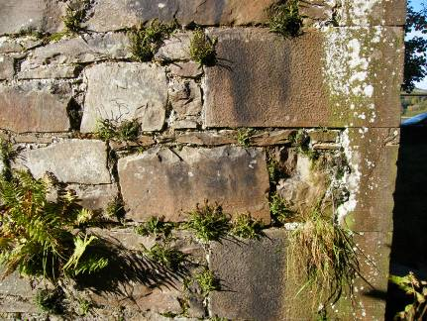 | 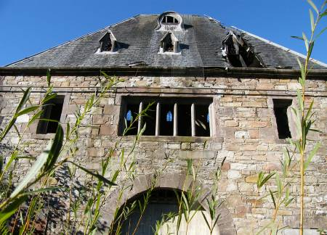 | 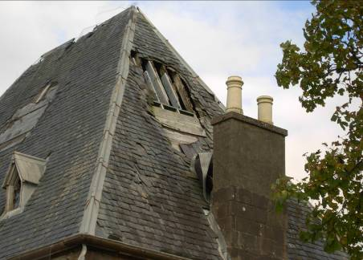 | 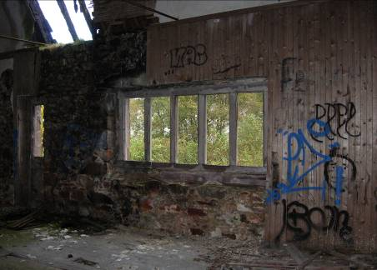

Figure ??: Examples of disrepair to the building
- Conservation philosophy

Having identified the significance of the Clock Lodge in section 3 above, our overall policy can be used to provide a philosophy for this project which is summarised in the following section of this report.

Level of Significance | Importance | Conservation Management Policy
A Exceptional | International | Reveal, maintain and enhance through meticulous preservation and conservation.
B Considerable | National | Reveal, maintain and enhance significance but some adaptation and supplementary construction may be considered to accommodate future compatible uses.
C Moderate | Local | Reveal, maintain and enhance significance but acceptable options may, subject to mutual agreement based on expert analysis including alteration or removal in whole or in part
D Neutral | Local Site | Interventions of a greater extent and alterations and even demotion may be acceptable.
E Little | Detrimental | Alter, remove or demolish the setting and character of the asset.
The table above indicates management policies appropriate for different levels of significance and is derived from guidance in the Burra Charter.

Section 3 above has identified different areas and categories of significance for the Clock Lodge. Application of the conservation management policy in the table above to these provide a basis for the conservation philosophy for this project.

Overall, the building has been assessed as of moderate to considerable significance. As such any proposals for its future should Reveal, maintain and enhance its significance but some adaptation and supplementary construction may be considered to accommodate future compatible uses.

Of particular importance to retain and repair are:
- The physical presence of the building and its symbolic status as a gateway to the Kilmory Estate. In spite of recent development the building retains a buffer of trees and these should be maintained as far as possible to contain the damage to the building’s setting.
- The original proportions of the building.
- The variety of detailing identified above which gives the building its special character.
- The original interior layout and the proportions of the rooms therein particularly to the ground floor although the openness of the upper room is also considered important.
- As much original fabric including internal finishes and remnants of fittings as possible.
- The sliding pocket doors.

Capable of accepting alteration are:
- It is considered that a sensitive extension to the building could be acceptable provided that it is diminutive in proportion and reflects the symmetrical nature of the Lodge.
- There is potential for insertion of a second floor in the volume of the existing first floor space.
- Sensitive development of the site which retains the buffer of trees. This may be better accommodated to the south (Joint Campus) side of the site.

Specific principles for the conservation of the Clock Lodge can be encompassed in the phrase as much as necessary but as little as possible and should include:
- Repair of the historic fabric using conservation best practice encompassed in the various international charters, BS 7913: 1998 “The Principles of the Conservation of Historic Buildings”, consultation with Argyll & Bute Council, Historic Scotland and compliance with current historic buildings and sites legislation.
- Reveal and retain as much of the original lodge to allow future users to understand the classical proportions of the original building.
- Use surviving interior timber fittings to inform like for like reinstatement.
- Sensitive design of interior alteration to respect the historic fabric.
- Conservative repair of exterior fabric.
- Finding a use that provides for the long term care and maintenance of the site and for it to be accessed by as many people and as diverse a range of people as possible.
- Employment of sustainable techniques and appropriate traditional methods of repair, construction and ongoing management.

- Threats, vulnerabilities and opportunities

The Clock Lodge is included on the RCAHMS Buildings at Risk Register (ref 1421). It has been unused for decades and as a result has not been a priority for the Council. It has been under-maintained and a target for vandals. The result is that a number of small fires have damaged the roof and overall the building is in a state of serious disrepair.

Attempts by the Council to dispose of the building and its site have been unsuccessful despite the attractiveness of the site, it is clear that the Clock Lodge is considered a blight by developers and thus the chances of a commercial disposal, particularly in the current economic climate are slim.

The key challenge of the building is its considerable size in relation to the less than convenient accommodation provided. The addition of its poor condition is bound to lead to a considerable conservation deficit and this makes it unattractive for commercial development.

The proximity of the A83 has a major impact on the Clock Lodge because it in effect forms a dam across the Lodge site preventing water from draining naturally into the Loch. It also creates noise and actual pollution which impacts on the building as well as potentially leading to vibration due to heavy lorries passing.

Despite the apparently good access to the building it also lacks a vehicular driveway off the main road, the status of the A83 as a trunk road may complicate the formation of a new access, this issue is discussed further in later sections.

At the other end of the scale there are opportunities for the Clock Lodge these include:

- Its location and site: the site is attractive for development because loch side sites are rare. This means that development of the site could unlock funding to address the conservation deficit.
- The interest of the local community in saving the building. A well motivated and organised community group has access to a range of funding sources that could help to address the conservation deficit.
- A range of possible uses that a community could promote in the building (see later sections).
- The willingness of Argyll & Bute Council to work with the community to find a solution for the building.

Overall, while the building is at considerable risk there is now an opportunity to act to find a viable and sustainable community led use for it and a development solution for the site that complements the buildings significance.

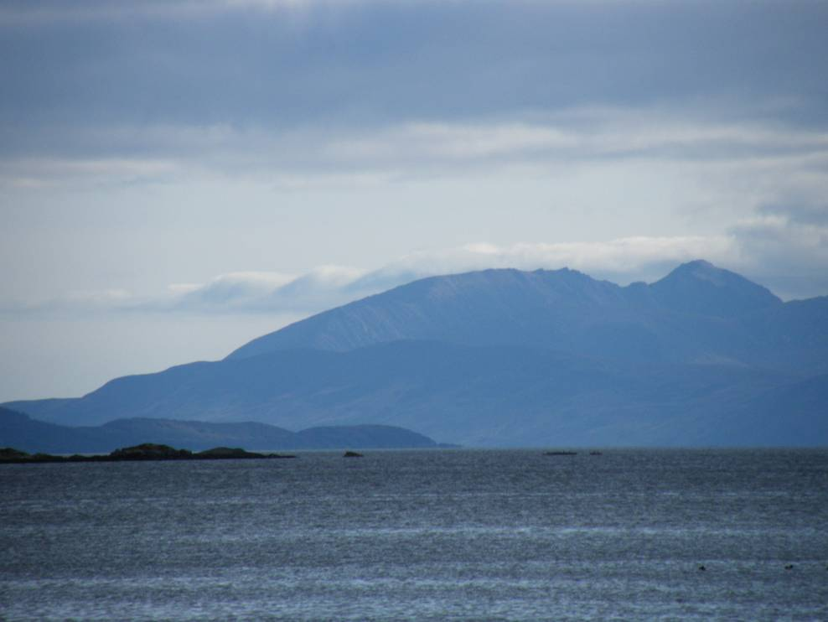

Figure ??: The view over Loch Gilp towards Kintyre from the Lodge
Simpson & Brown Architects

- Condition & repairs required

The consultant team visited the Clock Lodge in October 2012 and have undertaken surveys to establish the condition of the building, they are also in possession of the 2009 Gleeson report and this will inform an outline repair schedule which will be produced shortly. An estimate of costs will be prepared by Hardies against this schedule. This will provide a baseline cost for works which would amount to a shell repair of the building. The costs of fees and miscellaneous expenses, adaptation, conversion, extension and site infrastructure will be added to these costs to provide a complete cost for the various options.

The following pages provide a summary of the building’s condition with sketches produced by Simpson & Brown Architects which incorporate structural assessments by Will Rudd Davidson.

In summary, the building is in poor condition and requires considerable repair. The bulk of historic fabric remains however, and where elements are beyond repair there are other examples which will inform replacement. Critical issues for the lodge are:

- Fire damage and rot to the roof structure.
- Damage and rot due to water ingress.
- Loss of original window formations.
- Damage to and loss of internal fittings and finishes.
- Loss of adequate water conductors.
- Poor drainage to the site.
- Overgrown site and vegetation growth.
- Lack of services.
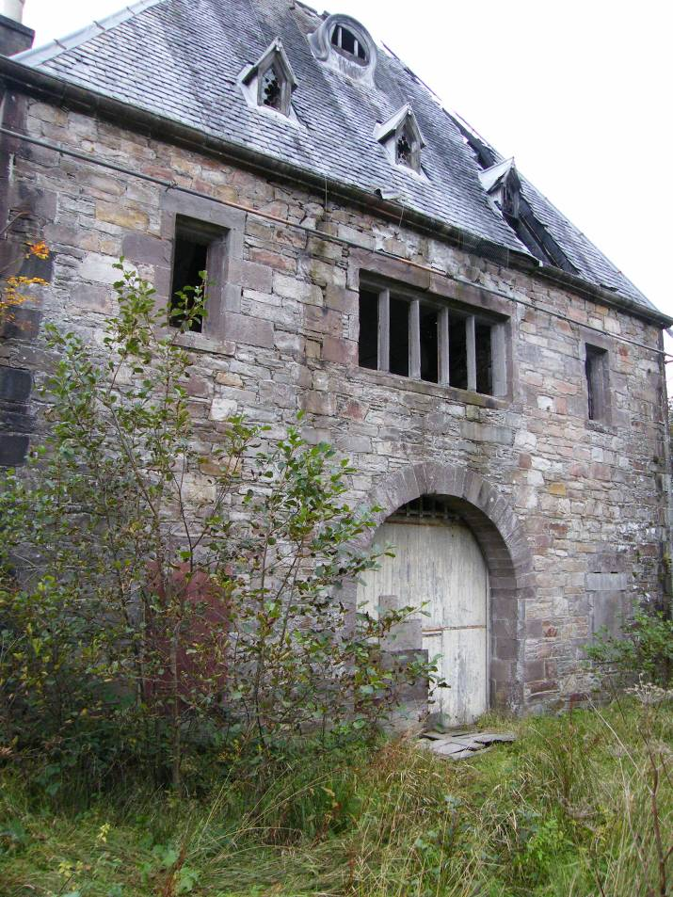

Figure ??: The east elevation Simpson & Brown Architects

S&B sketches will be inserted here see attached for the time being.
- Context

Physical context

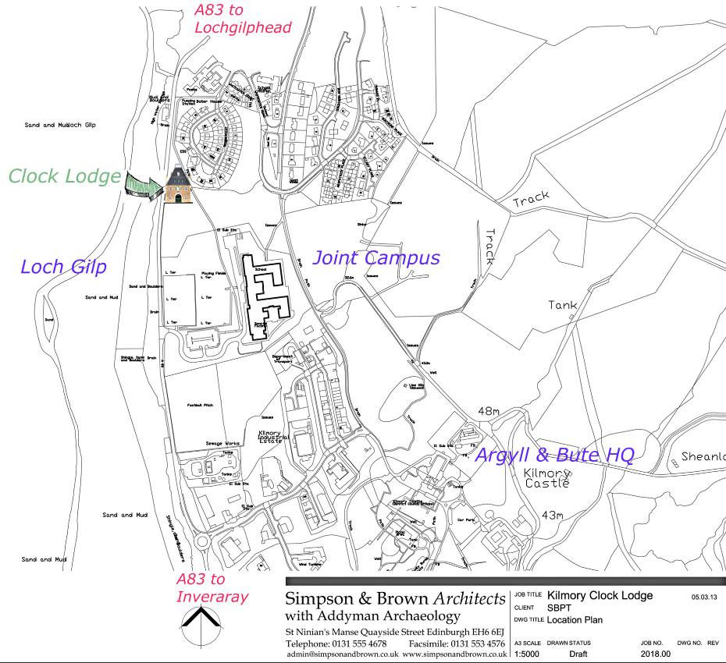

Figure??: Locational context of the Clock Lodge
As described in Section 1 of this report, the Clock Lodge is located on the edge of Lochgilphead adjacent to the new Joint Campus. The site is heavily influenced both physically and environmentally by the proximity of the A83 which runs directly in front and to the west of the building and cuts it off from the Loch and the causeway.

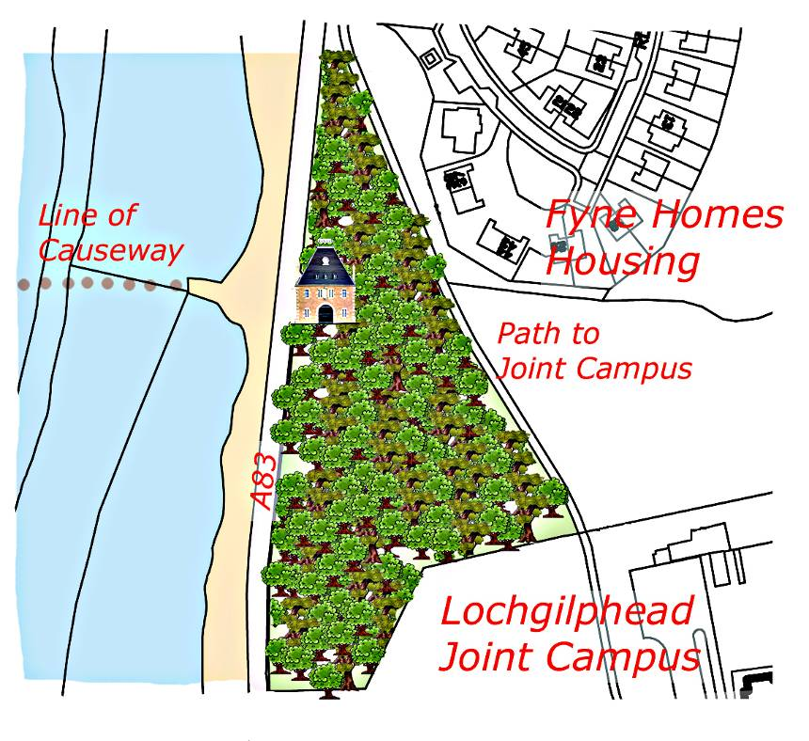

Figure??: Clock Lodge site plan and immediate environs
Transport links for Lochgilphead are exclusively by road and thus in one sense the Clock Lodge could be said to be well located in terms of transport. But the lack of parking and distance to bus stops means that it is quite peripheral. Both issues could be addressed in a new scheme.

Legislative context

The Clock Lodge is a category B listed building. The governing legislation for the management of listed buildings in Scotland is the Planning (Listed Buildings and Conservation Areas) (Scotland) Act 1997. The Scottish Historic Environment Policy (SHEP) published in July 2009 sets out Scottish Ministers’ policy for the historic environment and provides a framework to inform the day to day activities of those with a role and interest in managing the historic environment. It is interesting to note that the SHEP begins with the words: “Scotland’s historic environment contributes to the Scottish Government’s objectives and to the National Performance Framework”. This statement confirms the historic environment as a key part of Scottish Government thinking. Alongside this national policy stands the Scottish Planning Policy 23 (SPP23), published in October 2008, which supersedes NPPG 18 and NPPG 5. It is worth noting that the SHEP is currently undergoing review and a new policy will be published later in 2013.

The Memorandum of Guidance published in 1998 has now been superseded by Managing Change in the Historic Environment Guidance Notes it is these and the new SPP23 that planning authorities are directed towards in considering applications for listed building consent.

SPP23 states that:

The conservation and management of the historic environment contributes directly to sustainability in a number of ways. These include the energy and materials invested in a building, the scope for adaptation and reuse and the unique quality of historic environments which provide a sense of identity and continuity in a period of rapid social and economic change.

The historic environment can play a key part in promoting sustainable economic growth and regeneration by offering attractive living and working conditions that will encourage inward investment. It is of particular importance for supporting the sustainable growth of tourism and leisure.

On the issue of listing, the Policy includes the following:

Listing covers the whole of a building including its interior and any ancillary structures within its curtilage provided these were constructed before 1 July 1948. Change should be managed to protect a building’s special interest while enabling it to remain in active use.

Both the SHEP and SPP23 emphasise the need to provide continuity of use for historic buildings and areas. They promote the use of informed and sensitive adaptation where this is appropriate and possible, to allow buildings to come back into use and to evolve to accommodate the changes required by modern society. The policy also makes clear the important role of the Local Authority in managing the historic built assets within their area, by inclusion of specific policies in their Development Plans and by the preparation of Conservation Area Appraisals and Townscape Audits which help to inform planning policy and decisions.

The Argyll & Bute Council Local Plan became operative on 6 August 2009 and sets out current planning policy in the area. The new Local Development Plan will be adopted in the near future and this will change the area around the Clock Lodge from one designated for community allocation to one for potential development. Advice from Argyll & Bute Local Plans Team suggests that this will have minimal practical effect in relation to any proposals contained within this document.

The Local Plan includes policies specifically designed to protect Historic Buildings at LP ENV 13a and 13b, LP ENV 18 covers the protection and enhancement of buildings and comments that:

“Opportunities for the enhancement and re-use of existing buildings will be sought through proposals for re-building, re-use or change of use to maintain the fabric of the building and its value to the community. New uses will be approved in principle if:

- The amenities of surrounding properties and residents are safeguarded within the framework of other Structure and Local Plan policies;
- Access and car parking proposals fully meet the criteria set out in Appendix C;
- The proposed new use is consistent with other Structure and Local Plan Policies”

The Plan also sets out policies to encourage new and existing businesses and wider economic regeneration.

LP COM 1 provides a presumption in favour of new and improved community facilities in certain circumstances.

Design standards relating to Listed Buildings and Conservation Areas are contained in Appendix A to the Local Plan at paragraphs 16.1-16.3. This advice refers back to the SHEP and covers “all types of development from replacement windows to new houses or commercial buildings”.

There are no other designations of note affecting the Clock Lodge. NB requires confirmation. The proximity of the building to the lochside will need to be considered in any development and discussions with SEPA to confirm any specific areas of sensitivity will be an early requirement in the next phase of the project. Similarly, the A83 is a Trunk Road and therefore Transport Scotland will be a statutory consultee for any planning application relating to the Clock Lodge. Their guidance states:

Pre-application
Transport Scotland encourages pre-application discussions which allow the developer to provide details of the development proposal at an early stage.
This allows Transport Scotland to initially indicate the acceptability of proposals and provides the opportunity to highlight any relevant issues which may affect proposals and discuss the likely requirement for a Transport Assessment.

Consultations on Planning Applications

Planning Authorities must consult Transport Scotland before granting planning permission for developments which are likely to have an impact on the trunk road. The criteria for consultation is defined in Scottish Planning Policy and Planning Circular 1/2005: Notification of Planning Applications: Development affecting Trunk Roads and Special Roads.

The general criteria for applications to be referred to Transport Scotland is where the proposed application:

- is within 67m of a trunk road, or proposed trunk road
- requires a new or altered access
- will alter a new link to a proposed trunk road
- will provide refreshments, fuel or parking for motorway users

When assessing the acceptability of applications adjacent to, or affecting trunk roads, Transport Scotland will have regard to:

- Road Safety
- Operation
- Design Standards
- Transport and Traffic Impacts

Early discussions with Transport Scotland with particular regard to any new access are strongly recommended.

In addition to Planning law, the project design will of course need to take account of other pertinent legislation and in particular the requirements of the Scottish Building Standards, of particular interest will be the approach to Section 3: Environment and 6 Energy. The practical requirements of the Disability Discrimination Act 1995 will also be a key consideration.

Insert a paragraph on the interpretation of the planning and LB legislation as it relates to the CL – discuss with Lynda??

Ownership

The Clock Lodge is currently owned by Argyll & Bute Council. The Council have been working on a Third Sector Asset Transfer Policy and this is in draft. While it demonstrates a commitment by the Council to facilitate the transfer of property to communities, it is not particularly relevant to a redundant building such as the Clock Lodge. Advice has been sought from the Argyll & Bute Estates Department on the precise status of the Clock Lodge and how it might be transferred to the Lochgilphead Phoenix Project. Under normal circumstances, the Council would declare a building as surplus to requirements. This has not been the case for the Clock Lodge as the building fell out of use and quickly became unsuitable for use. In this case the following notes are provided by the Estates team.

(We) can’t provide you with a minute declaring the Clock Lodge surplus to the Council’s requirements but the property is surplus and has been so for many, many years.

Typically a property would become surplus following a rationalisation of offices, depots, etc, or the withdrawal of a service for a particular reason. To ensure public accountability surplus properties are almost always advertised for sale and any offers received assessed and reported to Council Committee. The Council may undertake a direct sale in certain circumstances, e.g. where there would be greater value selling to an adjacent proprietor.

The Council already made a decision to advertise the property and the Phoenix Project responded to the marketing campaign previously launched.

The view on transfer to the Phoenix Project is that the Estates Department is obliged to recommend that every effort is made to obtain a market value for the property but it may be that the Council will decide to deal directly with the Phoenix Project should this study prove positive and a business case is deemed acceptable.

Demographic and economic considerations

Population statistics

The 2011 census results are coming through but detailed local statistics are not yet available. The following information is therefore gathered from the 2001 census and from Argyll & Bute Council. The information is presented in summary to give an impression of the current situation only.

 | Lochgilphead | Scotland
  Sex
Total resident population | 2,326 | 5,062,011
- % Males | 46.69 | 48.05
- % Females | 53.31 | 51.95

 | Lochgilphead | Scotland
  Age
Total resident population | 2,326 | 5,062,011
- % 0-4 years old | 4.77 | 5.47
- % 5-15 years old | 15.69 | 13.73
- % 16-29 years old | 14.57 | 17.46
- % 30-44 years old | 21.97 | 22.97
- % 45-59 years old | 18.70 | 19.29
- % 60-74 years old | 14.96 | 13.98
- % 75 and over | 9.33 | 7.09
Total resident population | 2,326 | 5,062,011
- % under 16 | 20.46 | 19.20
- % 16-pensionable age | 58.04 | 62.19
- % pensionable age and over | 21.50 | 18.61

The key factors to draw from these statistics are that Lochgilphead has a slightly higher proportion of retired people than the rest of Scotland and perhaps more critically a lower proportion of people in the key economically active age range from 16-pensionable age.

Employment statistics

Employment statistics for Lochgilphead or Mid Argyll are difficult to determine the summary below is for Argyll & Bute as a whole and therefore not perhaps a true reflection of the local situation.
Employment and underemployment October 2011-September 2012

 | Argyll and Bute  (numbers) | Argyll and Bute  (%) | Scotland  (%) | Great Britain  (%)
All people
Economically active† | 42,400 | 77.8 | 77.0 | 76.7
In employment† | 39,400 | 72.0 | 70.8 | 70.5
Employees† | 31,800 | 59.3 | 62.2 | 60.5
Self employed† | 7,200 | 12.2 | 8.1 | 9.6
Unemployed (model-based)§ | 2,800 | 6.6 | 7.9 | 7.9
Males
Economically active† | 22,900 | 84.0 | 82.1 | 83.0
In employment† | 20,800 | 75.8 | 74.9 | 75.9
Employees† | 15,600 | 58.5 | 63.0 | 62.0
Self employed† | 5,000 | 17.1 | 11.5 | 13.4
Unemployed§ | 2,100 | 9.1 | 8.7 | 8.4
Females
Economically active† | 19,600 | 71.8 | 72.0 | 70.5
In employment† | 18,600 | 68.2 | 66.8 | 65.2
Employees† | 16,200 | 60.0 | 61.5 | 59.1
Self employed† | 2,200 | 7.5 | 4.8 | 5.7
Unemployed§ | 900 | 4.8 | 7.1 | 7.4

Source: ONS annual population survey
† | numbers are for those aged 16 and over, % are for those aged 16-64
§ | numbers and % are for those aged 16 and over. % is a proportion of economically active
A particularly significant statistic here is the number of self employed residents in the area.

Economic inactivity October 2011-September 2012

 | Argyll and Bute  (level) | Argyll and Bute  (%) | Scotland  (%)
Total | 11,500 | 22.2 | 23.0
Student | 2,300 | 19.7 | 23.5
looking after family/home | 2,200 | 18.6 | 19.8
temporary sick | # | # | 2.5
long-term sick | 2,800 | 24.1 | 28.4
discouraged | # | # | 0.9
retired | 3,200 | 27.5 | 17.8
other | 700 | 6.4 | 7.1
wants a job | 3,300 | 28.5 | 24.8
does not want a job | 8,300 | 71.5 | 75.2

Source: ONS annual population survey
# | Sample size too small for reliable estimate
Notes: | numbers are for those aged 16-64
 | % is a proportion of those economically inactive, except total, which is a proportion of those aged 16-64

This table indicates the effect of the high proportion of the population who are of retirement age in relation to employment. What it doesn’t show is the spending power of the retired section of the population or their involvement in voluntary and community activities.

Average earnings by residence in Argyll & Bute in 2012 had dropped to £462.00 against the Scotland wide average of £498.30 reflecting the nature of employment across the region².

One other interesting statistic from this source is the number of businesses that are registering for VAT in Argyll & Bute (this statistic for 2007) at 6.8% against a national average of 10.3%. The suggestion here being that the businesses in the area are small and this ties in with the numbers of self employed people noted above.

In 2011 53 people were unemployed in Lochgilphead but 42.3% (Scottish average 38%) worked in the public sector. While this shields the area from the impact of seasonal employment which are common across the rest of the Highlands and Islands there is a vulnerability to this concentration which could lead to higher levels of unemployment in future as Local Authority cuts begin to bite.

Other areas of employment include real estate and letting providing 7.57% of jobs and hotels and restaurants providing 6.6%. This compares with 11.42% and 4.95% Scotland wide, the statistic demonstrating the significance of tourism in the area as a whole.

The Registers of Scotland Fact Sheet for Argyll & Bute published December 2012 is attached to this report. This gives a good snapshot of information for the region as a whole. A striking statistic is given on page 4 where the migration rates are illustrated in a table which is included below.

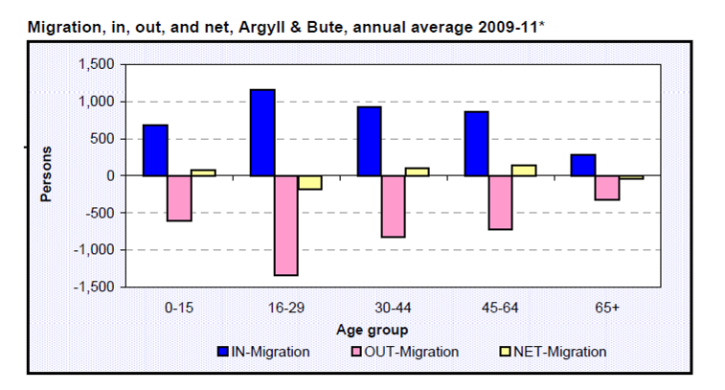

Figure ??: Migration rates: source National Records of Scotland

The slightly surprising conclusion from this table is that apart from the age groups 16-29 and 65+, the net migration is inward. Anecdotal evidence suggests that while many people leave Argyll & Bute in their late teens for education and employment reasons, they return to bring up their families in the area to benefit from the perceived higher quality of life in the area.

Scottish Indices of Multiple Deprivation

The Scottish Indices of Multiple Deprivation indicates that Lochgilphead is a relatively comfortable place. The Lochgilphead and Kilmory area do not fall within the most deprived 15% under any of the classifications given. The area beyond however, is classed in the bottom 5% in the classification Geographical Access. This relates to access to services and while the town of Lochgilphead is well served by public services, primary healthcare, schools, libraries etc (see below), the measure tends to ignore the geographical disadvantages of the location in relation to variety of services including major illness healthcare, housing for the elderly and those with special needs, arts and cultural activities and so on.

- Market Analysis and Consultations

The following is a summary of the analysis of the market conditions in and around Lochgilphead and of the public and focussed consultations that have been undertaken to support this appraisal. The full Market Analysis report is contained at appendix ?? to this report.

Lochgilphead is the administrative centre of mid Argyll, the headquarters of Argyll & Bute Council and Highlands and Islands Enterprise are located here as is a regional office for the Forestry Commission Scotland and the Mid Argyll Community Hospital. Argyll College has two centres in the town and the Joint Campus contains Lochgilphead High School which draws children from some 30-40 miles (the nearest alternative secondary schools are in Dunoon, Campbeltown and Oban). This concentration of public services in Lochgilphead distorts the market to some extent but also pehaps has the effect of making Lochgilphead a place for administration rather than a place for fun. That said, for active citizens the area has a wide range of well supported activities from sports clubs to arts to music. Outdoor pursuits are particularly well catered for including some highly thought of off road cycle routes, walking, running, canoeing and sailing. There is a 9 hole golf course at Lochgilphead but the major links courses are further down the A83 at Macrihanish and on Islay. There are several stables in the locality offering lessons and trekking.

For families, there are less challenging walking and cycling routes such as the Crinan Canal path. The Canal also attracts visitors and tourists as do the various archaeological sites clustered round (in particular) the Kilmartin Valley. The Kilmartin House Museum is a major centre for archaeology, with some ??? visitors last year. There are a further 13 heritage centres mostly run by volunteers in the Mid Argyll and Lorne area. There is no theatre, cinema or music venue in Lochgilphead although the Screen Machine visits every 6-7 weeks and is well attended. For residents who want to participate, there is a full programme of activities and clubs in the area. Lochgilphead does not have a full programme of events and festivals throughout the year although the Crinan Water Festival and Classic Boat Festival, the Lantern parade and are there not some games held in the summer??

2012 seems to have been a poor year for tourism across the Argyll area and figures for attractions such as Kilmartin House corroborate this. The impact of the Olympics and the bad weather seem to have deterred people from travelling beyond the Central Belt. Whether the market will pick up again this year remains to be seen. The impact of tourists on Lochgilphead is difficult to gauge. On the face of it, the town does not have the pulling power of Inveraray or Oban or even of Kintyre and the islands. The hotels in the town itself, do not offer particularly high quality accommodation, appealing more to the budget and business markets. There is also a caravan site in the centre of Lochgilphead. Higher end accommodation includes The Corran guest house. Close by however, are a number of more attractive hotels, guest houses, holiday cottages and cabins. For the self catering market in particular, Lochgilphead’s shops will be important and facilities such as the Mid Argyll Community Pool will draw visitors into the town. Hotels around Lochgilphead include the Grey Gull at Ardrishaig, a reasonable quality hotel but with frequent changes of management in the last few years. The Cairnbaan and Crinan Hotels offer good quality accommodation and Horsehoe Inn has a good reputation for accommodation (hotel and self catering) and its restaurant. Prices for local hotels range from £30 per night up.

There are a range of self catering options in the Mid-Argyll area from cabins at ?? to individual and estate cottages. A quick web-search reveals options in all price ranges.

For example:

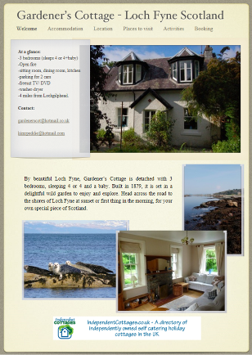£350-£425  per week  http://www.gardeners-cottage-loch-fyne.co.uk/Gardeners_cottage/Welcome.html | 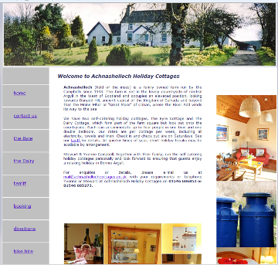£250-£340  per week  http://achnashellochcottages.co.uk/tarrif.htm

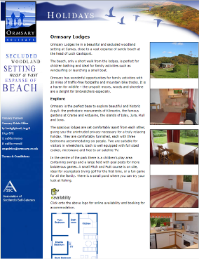£400 per week  http://www.ormsary.com/holiday_lodges.asp# | 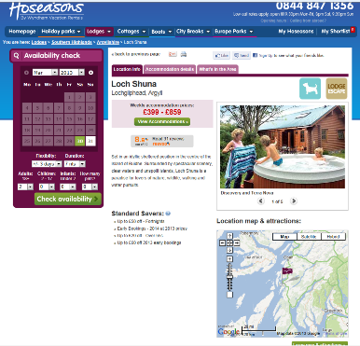  http://www.hoseasons.co.uk/lodges/loch-shuna-shun

There is a limited selection of restaurants open in the evening in Lochgilphead. The pubs provide reasonable, basic food particularly the Argyll Hotel, there is also an Indian restaurant but beyond this choice is very limited. Any others?

Mid Argyll is a popular place for artists to locate but most appear to work from home. The Dochas Gallery in the town has regular exhibitions of local and nationally recognised artists and there are also facilities for art shows at Kilmartin House and the Piggery at Taynish. The Archway Gallery in Lochgilphead is a retail gallery. Facilities for arts education are limited and the Colouring Ardrishaig project run from the Blue Dot shop in 2012 by ArtMap Argyll with funding from Creative Scotland demonstrated a real enthusiasm for such a venue.

The retail offer in Lochgilphead combines a good selection of independent shops with a reasonably sized Co-operative store. Although the residents of the area would like to see this offer widened to include specialist shops and on line shopping and trips to Glasgow are necessary to augment what is available locally, the range from fresh food to household goods to books and gifts is considered good. There is a good supply of workshops and offices in the town of varying quality, size and facilities.

There is a reasonable range of meeting and event space in the area, although a lot of this is provided by local hotels and local people tend to consider the options expensive. Facilities include:

- The community centre.
- HIE offices.
- Argyll & Bute offices.

The wedding market is well served at all levels of cost and elaboration, by venues from Inveraray Castle to the Crear and again in the local hotels.

Identifying gaps in the market is not entirely easy. There is pressure on housing in the area, particularly for young people trying to break into the housing market and for the elderly and those requiring support or specialist facilities. Lochgilphead does not have the wow factor of other Argyll towns in relation to tourist attractions, although it is in fact located at the heart of an area rich in heritage and outdoor activities. The Visotor Information Centre was recently withdrawn from the town and while a hub has been located in Fyne Tackle by Heart of Argyll who are promoting tourism and business in the area, information for tourists is not immediately easy to find in the town although a number of web-sites advertise the area. These include:

- http://www.lochgilphead.info/
- http://www.lochgilphead.biz/

There is a thriving arts scene in the area, which is becoming more visible as a result of the activities of groups like ArtMap Argyll and a limited number of locations for arts based activities and exhibitions.

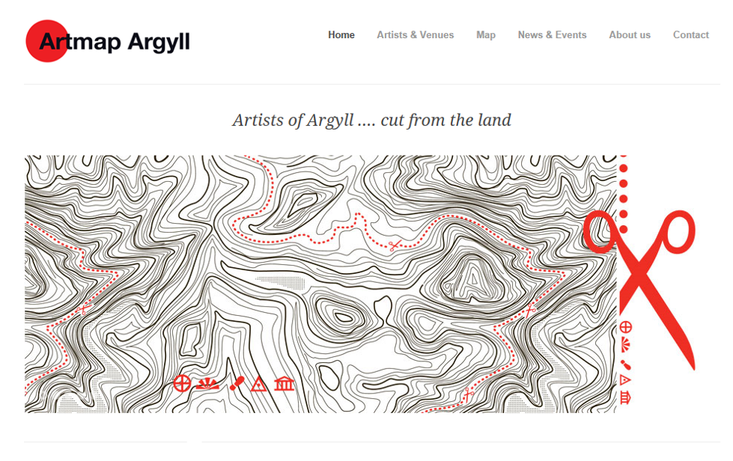

Figure ??: http://www.artmapargyll.com/

Consultations

The detail of the consultations undertaken as part of this appraisal are contained at appendix ??.

The LPP conducted a wide ranging survey in 2012 to determine the community’s improvement preferences. This highlighted the Clock Lodge as one of the key priorities for action.

The public consultation survey was distributed in hard copy form to the local Co-op, ACHA, Council offices, Community Council, Argyll and Bute Social Enterprise Network (ABSEN) and Mid Argyll Partnership members. It was also published on line on Survey Monkey. The process was publicised in the following ways:

- Articles in the Argyll Advertiser
- emails to all Argyll Voluntary Action's contacts
- emails to all Business Gateways contacts
- emails to local MSP and Councillors
- emails to all Council staff
- and more

The survey was divided into two categories, those from the general population and those from pupils at the Grammar School. The same pro forma was used for each, it asked people to comment generally on facilities that were missing in the area and specifically on what uses respondents would like to see at the Clock Lodge, various options were included and respondents were asked to rank them. There was an opportunity to propose other uses and provide comments.

Summary of general population responses:

Respondents were asked whether they would like to see the Clock Lodge saved if this was practical, over 56% said they would.

145 individual responses were received representing approximately 6.3% of the population of Lochgilphead. This is not then a particularly representative view. The low response could be due to “consultation fatigue” although compared with other areas where SBPT is working, the amount of consultation recently has been fairly low. It could represent a general disinterest or apathy about the town or could indicate that the population as a whole is not interested in this particular project. It is possible that most people in Lochgilphead are relatively comfortable with their current circumstances and as a result do not perceive any need for change or improvement.

Age profile:

- Nearly half the people responding were aged 30-50 (47.9%) a slightly higher figure than the population statistics
- Only 3.5% were over 70 lower than the general population statisitics
- Only 1.4% were under 18 lower than the general population statisitics
- 81.2% were between 30-70 higher than the general population statisitics

Just under 50% of those who responded were men (in our experience this is unusual, it is usually women who respond to surveys – perhaps this is because most of the responses were given on line?).

The consultation did not provide a conclusive steer on the use of the building although it did emphasise a number of themes and running through these was a clear desire to improve the visitor offer in Lochgilphead, to encourage more tourists to stay in the town and thus support the local economy. Public access to the building was seen as important.

Favoured uses were:
- Heritage Centre
- A facility for young people (detailed ideas differed)
- A restaurant
- A theatre / cinema / art gallery / event space
- Tourist accommodation - bunkhouse
Uses which were not wanted included:
- A public sector use
- A private house – unless there was no other way of saving it
The word “destination” and the idea that Lochgilphead needed a marketable identity came out in a number of responses.

The image below illustrates some of the recurring themes that came out of the consultations.


Insert summary of results from school survey.

The public consultation was followed up by a series of focussed consultations with local agencies and organisations. These have included to date:

Murdo, Kenny and Jane McLeod McLeod Contractors and Chambers of Commerce
Linda Haig ACHA
Sharon Webb Kilmartin Museum
Carron Tobin Heart of Argyll Tourism Alliance
David Adams McGilp Visit Scotland
Carol McGregor SOLAS
Lucinda Hopkinson ArtMap
Sharon MacQueen ArtMap
Ally Barber McKays
Lorn McKay McKays

A workshop was also held with the members of the LPP to gauge their views and discuss possible options. We sought ideas and potential collaborations. We considered the site and the building, how these two elements could be re-used discussed the pros and cons of various ideas. Overall the results of these discussions did not differ widely from the wider public consultation responses but we did obtain some clarity on some issues relating to the practicalities of developing the building and site, some useful local insight and some potential collaborations that could assist in the delivery of the project.

The LPP consider that Lochgilphead would benefit from a stronger and more marketable identity and that this should relate to themes arts, events, health and wellbeing and visitor destination.

The heritage centre concept (including ideas of archives) was generally unpopular with those working in heritage, tourism and marketing. Sharon Webb provided an outline of existing facilities commenting that there are some 13 local museums and heritage centres in the Mid-Argyll area. Many of these rely on volunteers to run and many are struggling. Funding for this kind of facility is difficult to find and there is a danger of displacement of visitors from other offers including Kilmartin. It is extremely difficult to make such a facility viable and of secure a suitable collection to exhibit and this is not therefore considered to be an option worth pursuing for the Clock Lodge, although the idea of a virtual collection via the use of IT and interpretation is considered a possibility. The idea that heritage and the history of the area should be celebrated and interpreted for visitors in Lochgilphead and possibly at the Clock Lodge was also welcomed.

Practical and financial issues in relation to the development of the building and site were discussed with the two developer / contractors. This gave a good insight into their position. Broadly, this is an attractive site because of its location in relation to the town and school and because it is on the loch side, a rarely available feature. The site is however, un-serviced, has no vehicle access, is poorly drained, has the main road directly adjacent to it and the existence of the Clock Lodge is a problem in pure development terms. In the view of the contractors, the conditions of repair for this listed building will increase overall cost and even a development of 10 residential units might struggle to provide sufficient funding to overcome the conservation deficit of the building. Both however, said that they would not be averse to exploring ways in which they could work with the LPP to develop a collaborative project. Further help was offered in the form of practical suggestions relating to access and servicing of the site and likely values and costs. This will be explored further and reported in the final report.
The view of the local RSL was given by Linda Haig from ACHA (this will be augmented by discussions with Fyne Homes in the final report). The key issues are that the three year housing strategy is in place now, so development to 2015 is agreed with Argyll & Bute Council. Whether the site could be brought into the next round of development is open for discussion but will depend on demand and strategy at that time. Development of housing is constrained by reduced funding for RSL’s and the cost of individual units is being squeezed by the Scottish Government settlement. This means that more “adventurous” developments such as those that might involve re-using historic buildings are harder to bring off. The wider role activities of the RSL’s are also being cut back due to lack of funding. A suitable project that addressed housing issues for example for young people between education and employment who need additional support (the niche foyer concept) might be worth exploring.

The view of the Heart of Argyll and Visit Scotland could be characterised as realistic in relation to the likelihood of making Lochgilphead into a “tourist Mecca”. A potential opportunity might be to offer accommodation for visitors who could experience the various attractions that surround Lochgilphead while providing seasonal support to local businesses. The notion of something to do on wet days was mentioned.

The sense that Lochgilphead needs identity and that this could be provided through an arts and wellbeing hub was expressed universally. The ArtMap contacts were positive about the idea of creating such a facility. The demand for gallery space with a proper hanging system (a white room) was expressed. Further research will be required to determine how robust this demand really is but the analysis of the market and the response to the consultations do suggest and opportunity here. The linkage between arts, events and wellbeing with the possibility of a site providing alternative therapies, art and craft, gardening and events seems worthy of further consideration.

The recent success of The Blue Dot Shop in Ardrishaig was mentioned, this initiative seems set to continue and there is an ambition to develop it further. This could tie in with the development of the Clock Lodge. Other possible connections and references include the work underway at Dunoon Burgh Hall and the recent success there in attracting an exhibition through the Artists Rooms scheme – could this happen in Lochgilphead, why not? The work of the Solas group of alternative therapists could augment this use for the site providing a centre for wellbeing (see appendix ?? for further input from Solas).

One example of a possible model for development of the Clock Lodge and its site in this way might be Cove Park on the Rossneath Peninsula. This and other related facilities (the Crear for insance) will need to be investigated in the next phase to inform this development but any Clock Lodge facility would have to develop its own unique selling point to ensure a secure future.

The possibility of a third sector run boutique hotel offering high end accommodation was also discussed and continues to be a popular option. Although quite unusual, there are examples of similar facilities such as the Yarcombe Inn in Honiton and the hotel on Gigha. Organisations such as the Plunkett Foundation promote community co-operatives such as shops and pubs.

- Discussion of potential options

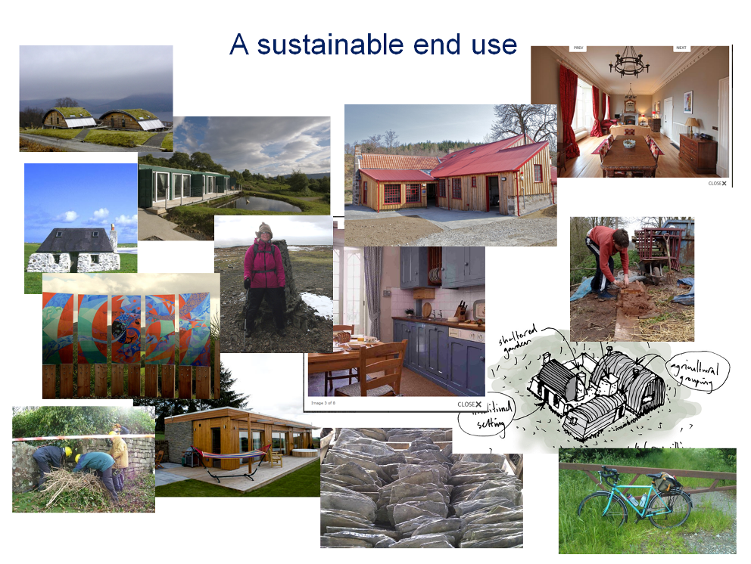

This project is considering a site and a building. The two can be looked at as a single development opportunity or as a building development plus a site development. So we could look at the project in the following ways:

- Develop the site to provide funds which would be ploughed into the building development – the pure enabling development option.
- Develop the building and site in a combined use.
- Develop the site in an income generating use to subsidise a sub-viable use of the building.
- Seek additional development land / financial input from ABC through development elsewhere to subsidise the capital cost of a site and building development.

The strongest theme from the consultation is to use this building and site to promote Lochgilphead as a place to visit. A single building cannot on its own turn Lochgilphead into a visitor destination, respond to all the needs and aspirations for the town expressed in the consultations or change the mindset of the community. What it may do is to encourage more visitors to stop here and contribute to the resilience of the town and the surrounding area by broadening the economic base. Ideas that are emerging might be characterised as follows:

- Development of a campus of holiday / visitor accommodation around the Clock Lodge, the latter to be utilised in a supporting role but maintained as a fairly flexible space available to the community.
- Site as above but with the Lodge in a complementary but separate use for example acting primarily as an arts hub with a flexible gallery space available to the community.
- Site as above but with the Lodge developed into bunkhouse type accommodation or a single unit for holiday letting (on a Vivat / Landmark model).
- Site developed for housing as enabling development with Lodge in one of the uses outlined above.
- Site developed for housing with the Lodge converted to a single residence.
- Site and Lodge developed in a single use eg as a boutique hotel providing high end accommodation and dining.

The relationships between these uses are illustrated in the matrix below.

Lodge options | Site options
Lodge options | Campus | Housing | Hotel
Community space |  |  | X
Gallery plus |  |  | X
Bunkhouse |  |  | X
Single residential unit for holiday let |  |  | X
Single residential unit for sale | X |  | X
Hotel | X | X

This analysis provides the following combinations of options for building and site for consideration as follows:

- Community space with campus
- Community space with housing
- Gallery plus with campus
- Gallery plus with housing
- Bunkhouse with campus
- Bunkhouse with housing
- Single holiday let with campus
- Single holiday let with housing
- Single residential unit for sale with housing
- Hotel

While the discussion in 8.2 above represents the favoured options (at this time), we need to determine objectively whether any of the options are realistic. Key questions should be applied to each on the basis of the market appraisal and community consultation above.

- Is it practical and appropriate for the conservation of the Clock Lodge?
- Is it a realistic use for the site?
- Is there a likely to be market for the idea?
- Could it produce a sustainable income (or a reasonable developer return)?
- Does it tie in with the mission of the LPP and would it have general support from the community?
- Is it practical for this use to be managed by a community organisation?
- Will it compete unacceptably with existing provision locally?
- Will it be possible to fund the capital work?

The matrix below gives an initial indication of the result of asking these questions for each of the uses outlined.

The use of ticks indicates a likely fit of use and question, the use of question marks indicates varying degrees of uncertainty or risk. X’s suggest that it is unlikely that the proposal will provide a positive result. The more risk, the less likely the option is to produce a successful result. It should be noted however that some risks such as those relating to the hotel use could be easily overcome should an operator or franchising method be found so this analysis could change as we move forward with the project. The biggest concern must be the ability of the end use to provide sustainable viability, without this capital grant funding is unlikely to be forthcoming and as the failure to market the building (despite the quality of the site) has illustrated, private investment alone is unlikely to deliver this project.

8.3 Qu | 8.2 Options
8.3 Qu | a | b | c | d | e | f | g | h | i | j
1 |  |  |  |  |  |  | ? | ? | X? | ?
2 |  |  |  |  |  |  |  |  |  | ?
3 | ? |  | ? |  |  |  | ? | ? | X?
4 | ?? | ?? | ? | ? | ? | ? | ? | ? | X | ?
5 |  | ? |  | ? |  | ? |  |  | X
6 |  |  |  |  |  |  |  |  | X
7 | ? | ?
8 | ? | ?? | ? | ? | ? | ? | ? | ? | X | ?

On the basis of this simple analysis, it would appear that the most likely options to succeed in this case are:

- Bunkhouse with campus
- Bunkhouse with housing
- Single holiday let with campus
- Single holiday let with housing

The public benefit, public support, enthusiasm and potential collaborators in ArtMap that could be connected with the arts hub / gallery space would however, incline SBPT to include this for consideration.

The hotel idea could be deliverable if a suitable operator could be found or a suitable management model could be devised. The existing visitor accommodation offer is generally of a lower standard and it may be that there is a market for high end hotel / guest house type accommodation in the area (and little competition or concern about displacement). Many local people expressed a desire to have a good restaurant in the town, a café bar was also on the wish list and the potential for this facility to accommodate community events should be explored. Models that might provide relevant data could include community owned pubs.

Any objective appraisal must consider the options of doing nothing and demolition. The inevitable conclusion of the do nothing option in this case, is the continued deterioration of the fabric of the Clock Lodge. This will have the following consequences:

- Loss of historic building fabric.
- Increasing risk of danger from the building to the general public.
- Costs of undertaking work to make the building safe.
- Blight on the site.
- Possible magnet for crime.
- Negative impact on this important approach to Lochgilphead.
- Negative impression therefore given of the place and the town.
- Reputational damage to Argyll & Bute Council in relation to management of own historic buildings and treatment of Lochgilphead.
- Community loses confidence.
- Damage to economic resilience and marketability of Lochgilphead.

In addition to these key consequences, not doing anything in these circumstances, risks missing an opportunity to save this important historic building and putting it into a productive modern use to the benefit of the town and the local economy.

Demolition is a last resort option in this case. Should the Clock Lodge be allowed to deteriorate further, the gradual removal of elements probably beginning with the roof will be inevitable to maintain public safety. This action has been seen elsewhere to lead to an almost inevitable sequence of down takings resulting ultimately in the loss of the building. The Clock Lodge is a category B listed building and permission would need to be sought for its demolition from the Local Planning Authority. This application would be referred to Historic Scotland and as discussed in section ?? above, the SHEP tests would then be applied. While Argyll & Bute Council have attempted to dispose of the building on the open market, it is not considered that every avenue for retaining the building has yet been explored and this exercise could be taken as a further step in that process. If this appraisal suggests a realistic possibility of a repair and re-use project being deliverable, then the Council as owners of the building have a duty to pursue that possibility.

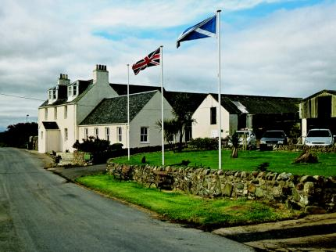

Figure ??: The Gigha Hotel owned and run by the Gigha Trust
- Preferred options

The following is a more detailed consideration of the three options for the building and 2 options for the site that have emerged from the preceding discussion.

Awaiting final sketches from Simpson & Brown, costs for works and valuations.

I will provide an analysis of the site uses and I am inclined to get some views from McKays in relation to access and drainage.

We should also go back to the two developers with the site sketches that show housing and get their comments on density and likely viability.

I think the section will be laid out as follows.

- Housing & bunkhouse
- Possible layouts
- Delivery options
- Brief discussion of management issues
- Costs
- Values
- Funding
- Assessment of deliverability including developer opinion

- Holiday campus & bunkhouse
- Possible layouts
- Delivery options
- Brief discussion of management issues
- Costs
- Values
- Funding
- Assessment of deliverability

- Single holiday let with campus
- Possible layouts
- Delivery options
- Brief discussion of management issues
- Costs
- Values
- Funding
- Assessment of deliverability

- Single holiday let with housing
- Possible layouts
- Delivery options
- Brief discussion of management issues
- Costs
- Values
- Funding
- Assessment of deliverability
- Assessment of deliverability including developer opinion

- Art space with campus
- Possible layouts
- Delivery options
- Brief discussion of management issues
- Costs
- Values
- Funding
- Assessment of deliverability

- Art space with housing
- Possible layouts
- Delivery options
- Brief discussion of management issues
- Costs
- Values
- Funding
- Assessment of deliverability
- Assessment of deliverability including developer opinion

- Hotel option
- Sketch scheme
- Delivery options
- Brief discussion of management issues
- Costs
- Values
- Funding
- Assessment of deliverability

- Legal and ownership issues

I need to do a bit more research on the web looking at how other community facilities are run and such like and draw up a transfer methodology for discussion with ABC.

- Implementation strategy

TBC

- Conclusions

TBC

NB in the Page & Park report, it is suggested that the ‘clocks’ to the north and south elevations were in fact fan lights or round dormer windows. Certainly in the 2002 photographs, the south ‘clock’ has a glazed, segmented face that looks perhaps more like a window than a clock. Whether therefore, all four pitches contained clocks is to be confirmed.
William Hook was the first director of the Botanical Gardens at Kew.
Orde was charged with whipping a child whilst driving his carriage, he was cleared of the charge. This incident happened long after the Clock Lodge was constructed however.
Although it is also widely believed that Graham’s main inspiration was Colonel Francis Cecil Ricardo CVO CBE (1852–1924), the first owner of a car in Cookham in Berkshire, where Grahame wrote the book.
Although the Red Lodge is notable for being a brick house in an area dominated by stone. The Lodge is now somewhat disfigured by the recent application of dry dash which has rendered its name somewhat redundant.
Although whether this fireplace is large enough to heat the considerable volume of the upper chamber is questionable.
The Broadstone lodge (demolished) is almost certainly later than the Clock Lodge, built around 1870 but its basic form is very similar to the much altered Luscar Lodge of about 1840.
http://www.scrol.gov.uk/scrol/browser/profile.jsp?profile=Population&mainArea=lochgilphead&mainLevel=Locality
http://www.nomisweb.co.uk/reports/lmp/la/2038432124/report.aspx?town=lochgilphead#tabempunemp
The possibility of a community run old people’s home was investigated by the community in Ardrishaig some years ago.
http://www.heartofargyll.com/
http://www.plunkett.co.uk/whatwedo/Co-operativepubs.cfm
Argyll & Bute Council themselves.
Michael Davis 2008: Kilmory Home Farm, Lochgilphead: “An assessment of architectural, historical and social significance” for Strathclyde Building Preservation Trust
Michael Davis 2002: The Clock Lodge, Lochgilphead: “An assessment of architectural, historical and social significance”

