Clock Lodge, Kilmory
Condition Report

December 2021
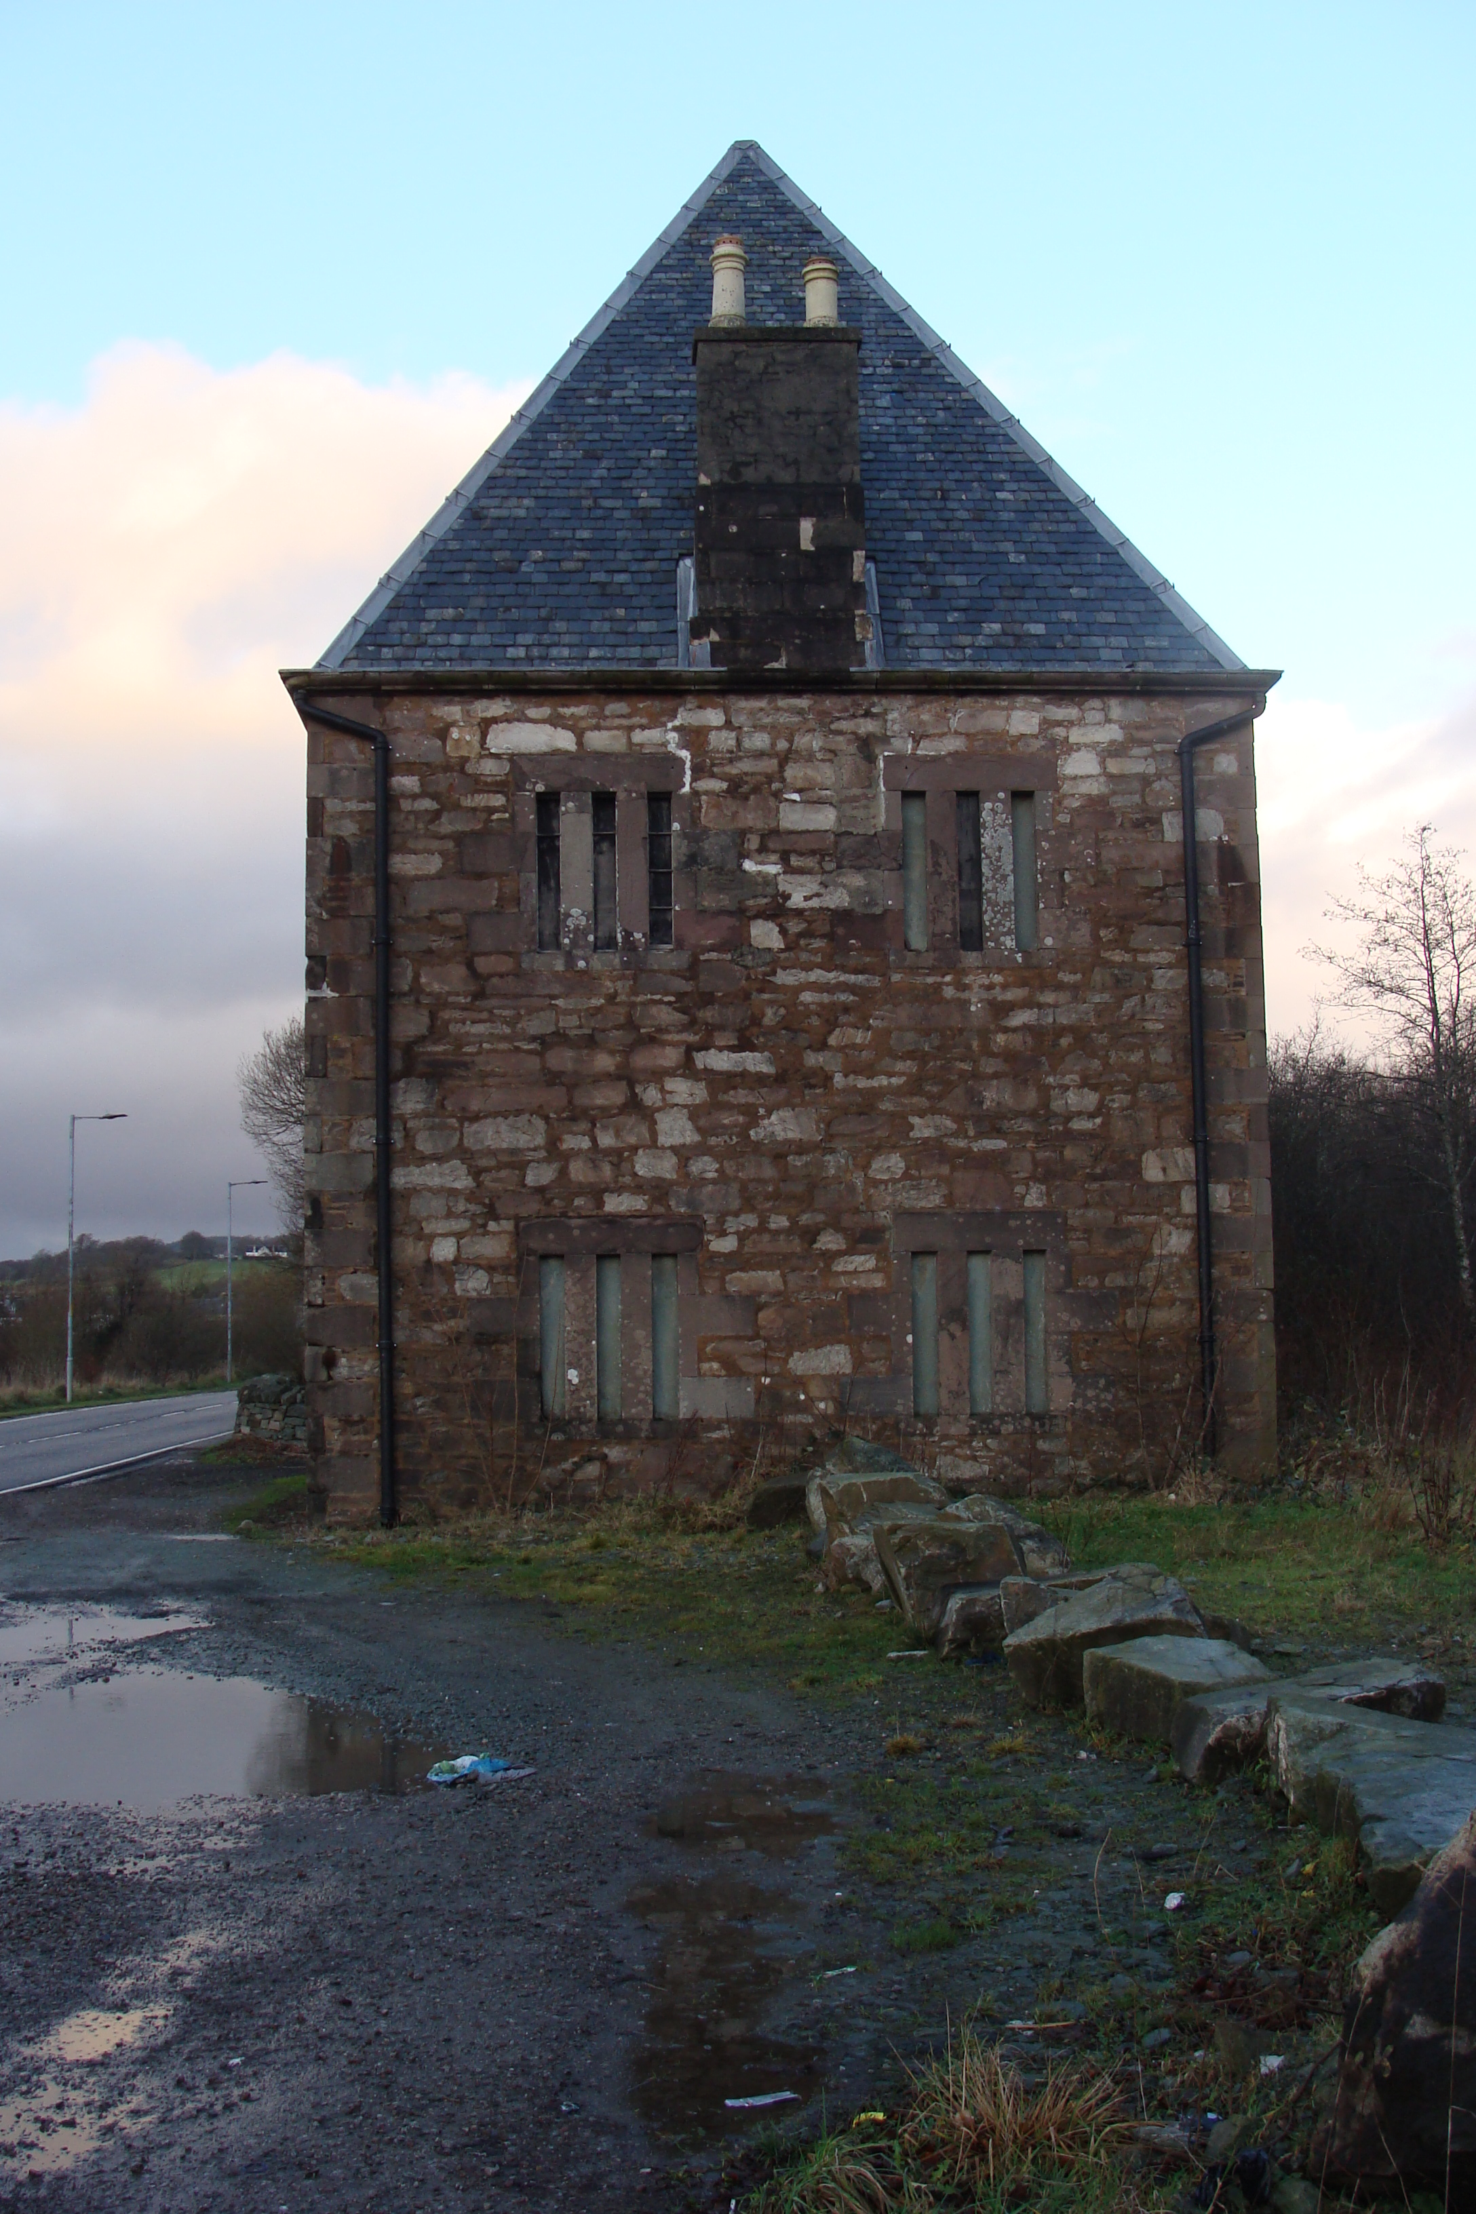 | 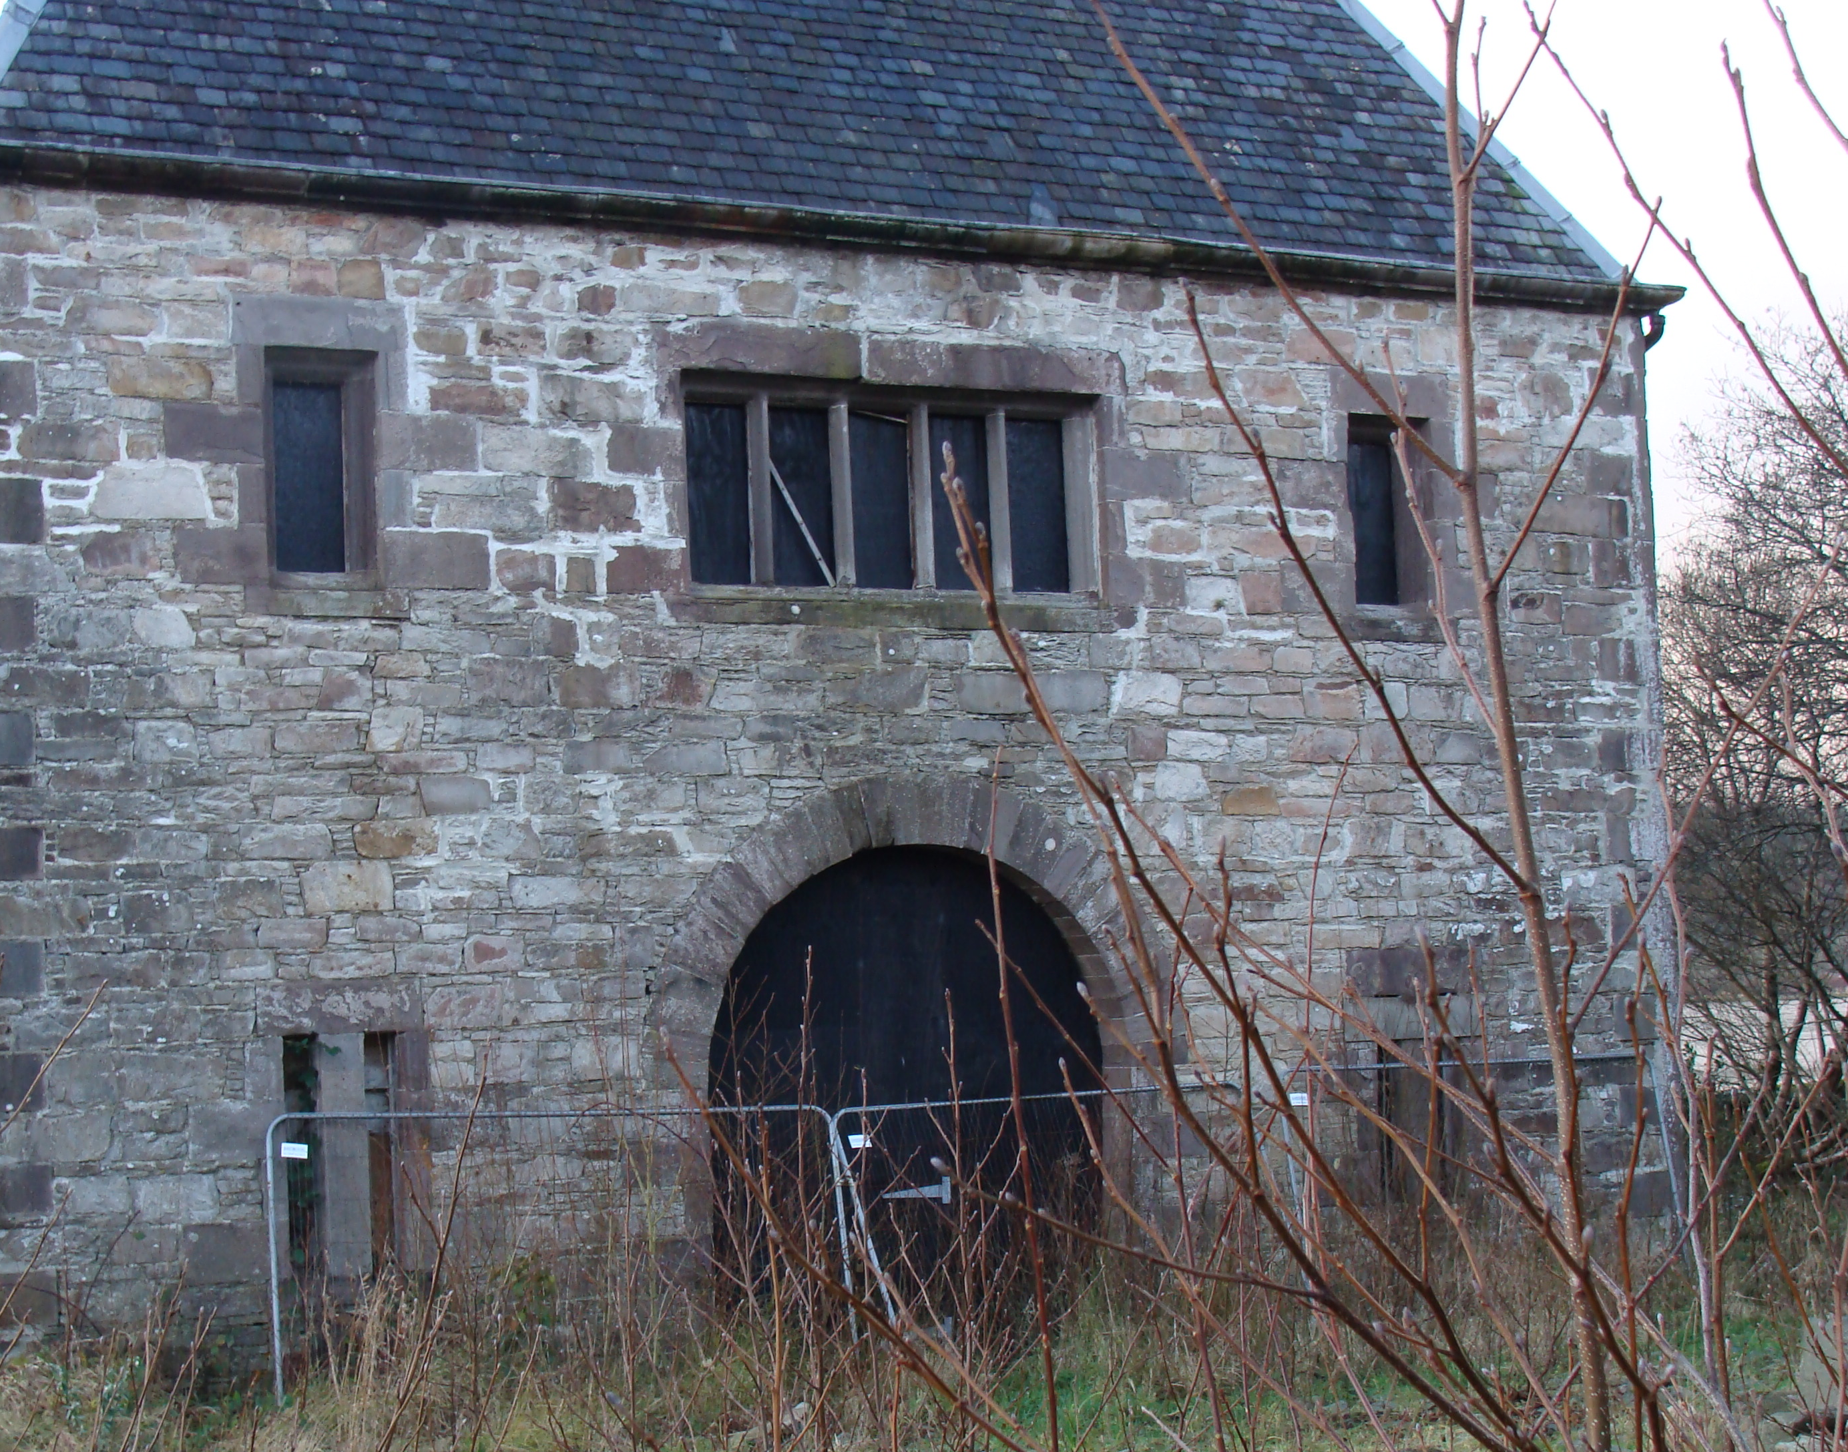 | 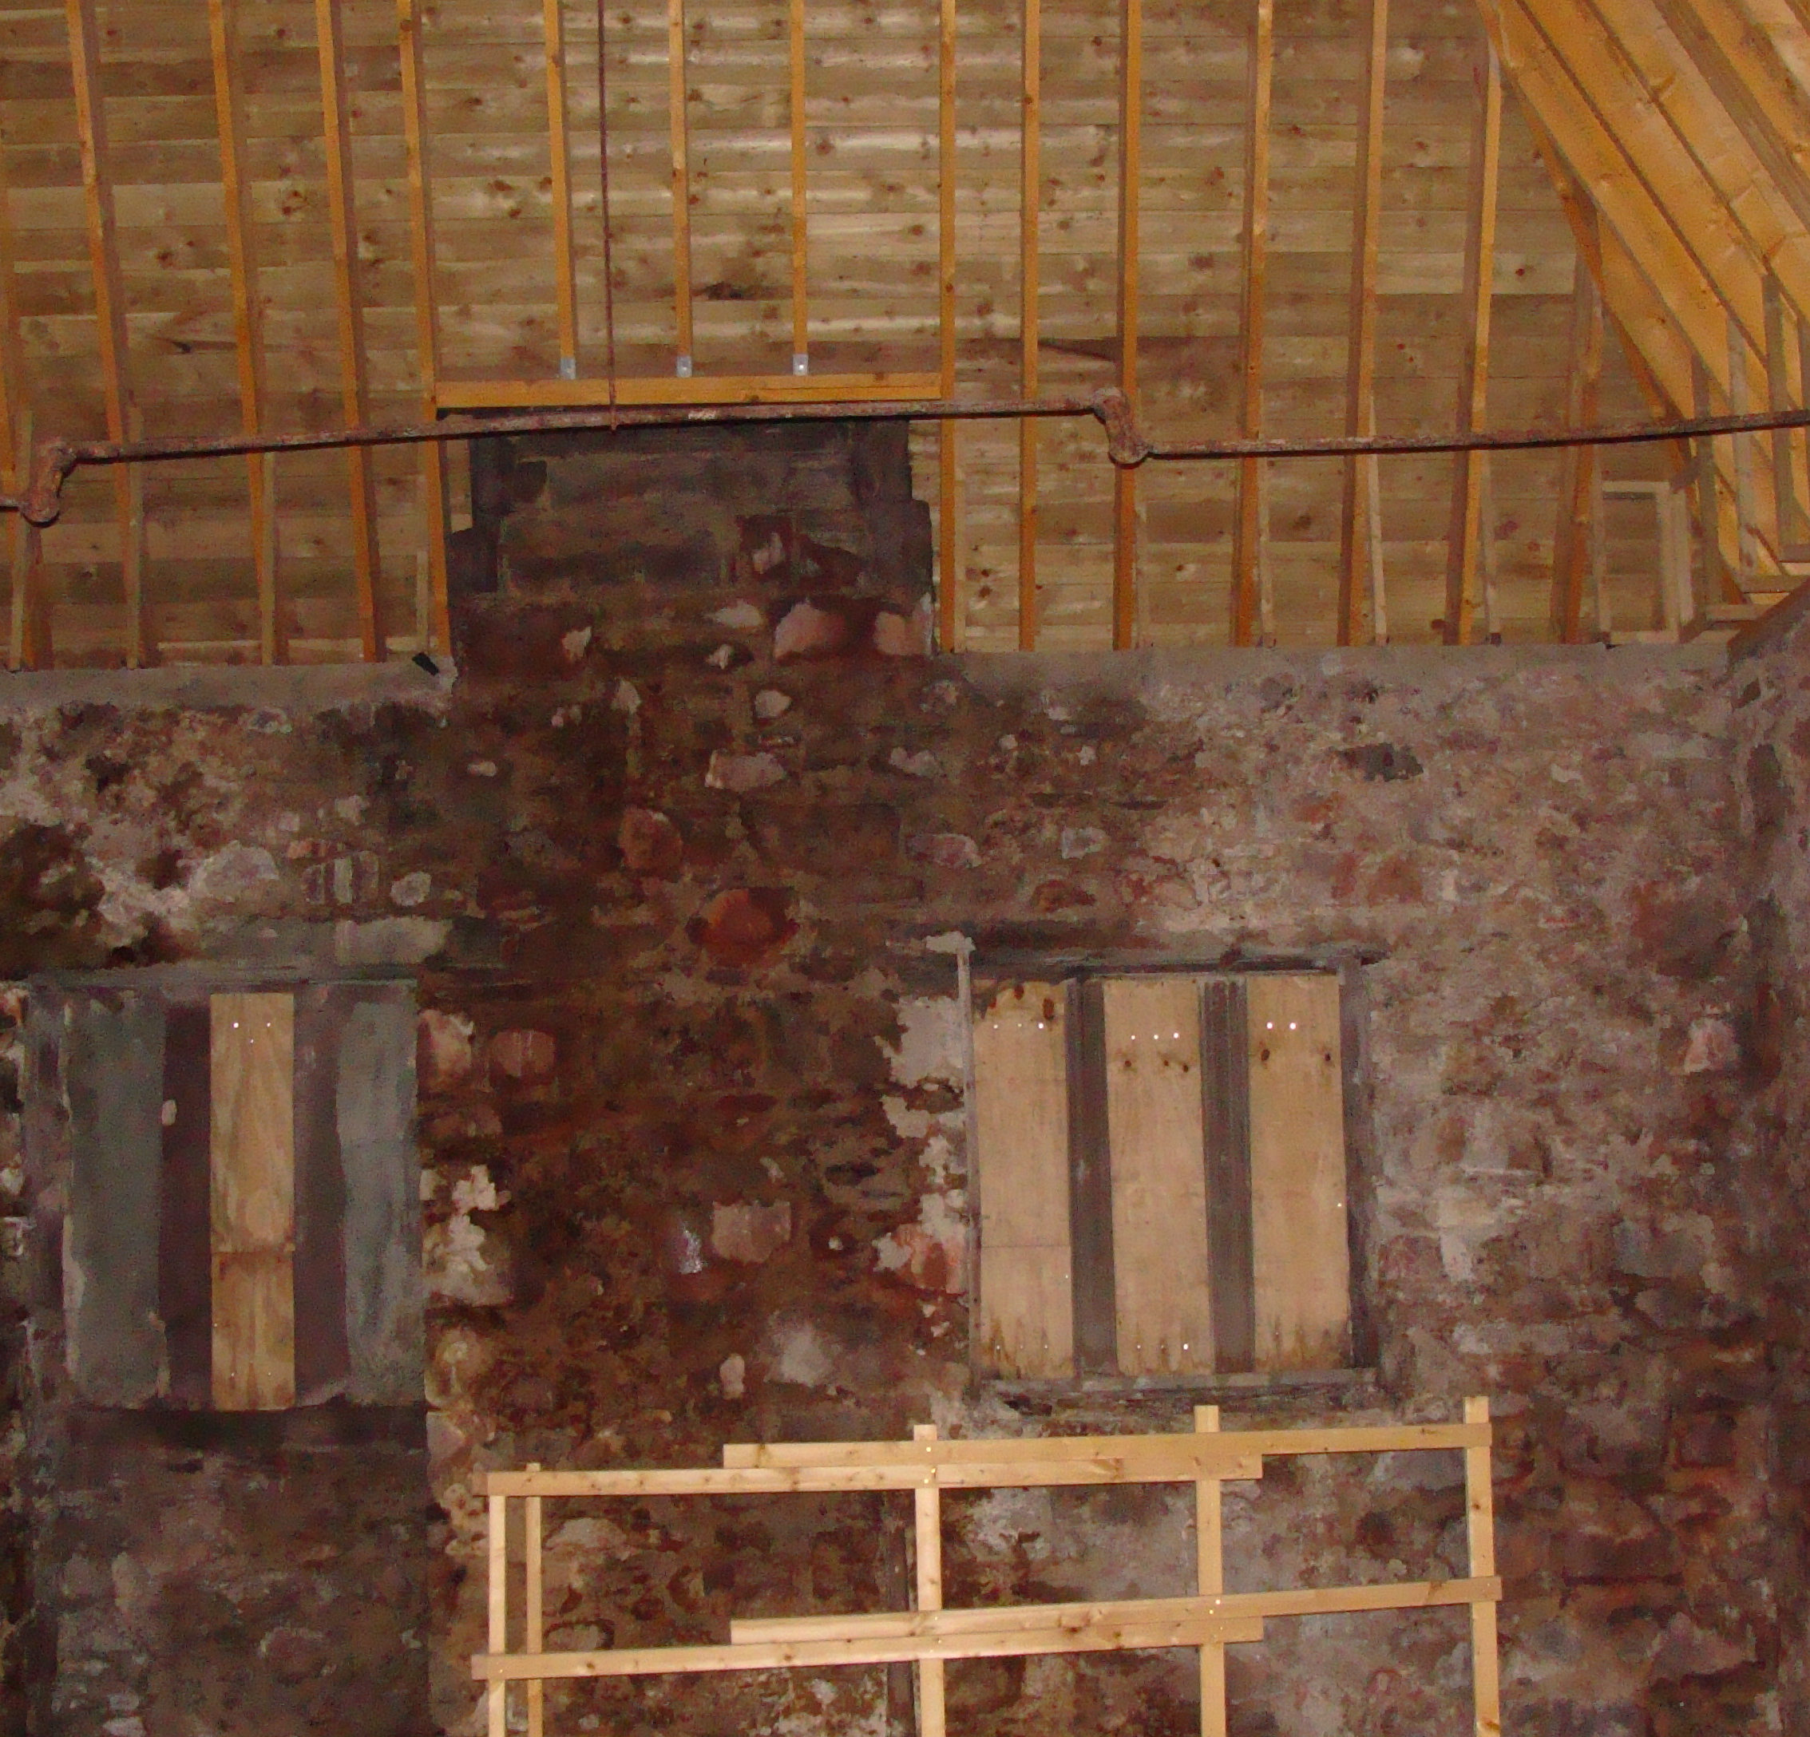
 |  | Simpson & Brown


The Old Printworks, 77a Brunswick Street, Edinburgh, EH7 5HS | 70 Cowcross Street, London, EC1M 6EJ | admin@simpsonandbrown.co.uk | +44 (0)131 555 4678
www.simpsonandbrown.co.uk
Primary author | JRS
Checked/approved | JRS
Issue number | 1

1.0 INTRODUCTION 1
1.1 The Purpose of the Report 1
1.2 The Consultants 1
1.3 Previous condition surveys 1
1.4 The Building 1
1.5 Condition Summary 2
1.6 Limitations 3
2.0 HISTORY AND SIGNIFICANCE 3
2.1 History of the Property 3
2.2 20th Century History 4
2.3 The Architect 4
2.4 Significance 5
3.0 Detailed inspection of the fabric 6
3.1 West Pitch 6
3.2 South Pitch 7
3.3 East Pitch 7
3.4 North Pitch 7
3.5 North Chimney 7
3.6 South Chimney 8
3.7 West Wall 8
3.8 South Wall 9
3.9 East Wall 10
3.10 North Wall 11
3.11 Internal Structure 12
3.12 Roof Structure 12
3.13 Upper Room – internal wall faces 12
3.14 Floor Structure 12
3.15 Ground floor 12
3.16 Stairs 13
3.17 Internal Walls 13
3.18 Internal Timber Mezzanine 13
3.19 Sliding Timber Doors 13
3.20 Drainage 13
4.0 REcommendations 14
4.1 Repairs Schedule 14

INTRODUCTION

The Purpose of the Report
The aim of this report is to confirm, as far as possible, the structural condition of the building. It also aims to identify any significant intrinsic structural issues that may impose constraints to the proposed repair works.
This report is a record of the present condition of the fabric of the building and provides an outline of the repair work required.
When the inspection was carried out most parts of the buildings were accessible. The upper walls were examined from the ground. The roof space is open to the space below and so is visible from first floor level.
In making recommendations, the aim has been seen as being to put the buildings into good working order, while maintaining a balance between the need to repair economically and the desire to conserve significant existing fabric, whether original or secondary, and to restore and enhance the appearance of the building.
Great importance is attached to the need to maintain the building systematically and continuously, and it is hoped that this report will form the basis of such an approach. Subsequent architect’s inspections at five yearly intervals are advised.

The Consultants
The report was written by John Sanders of Simpson & Brown Architects during December 2021. The weather was fair on the day of inspection.

Previous condition surveys
An outline general condition survey of the building was undertaken by Simpson & Brown in October and November 2004. This included an assessment by Will Rudd Davidson engineers. It also benefited from a previous survey by John Gleeson, an experienced buildings surveyor with a particular understanding for conservation. A structural assessment of the building was carried out by Wren & Bell in October 2004, and the service installations were inspected by Ian Low Associates in September 2004.

The Building
The building is stone-faced with brick internal loadbearing walls. The steeply pitched hipped roof is slated with Scots slates. There are chimneys on the north and south walls.
The first floor is supported by steel beams and masonry arch infills under a timber floor finish. The roof has been replaced in an initial phase of repair.
In this report the side facing the public road is assumed to be west.
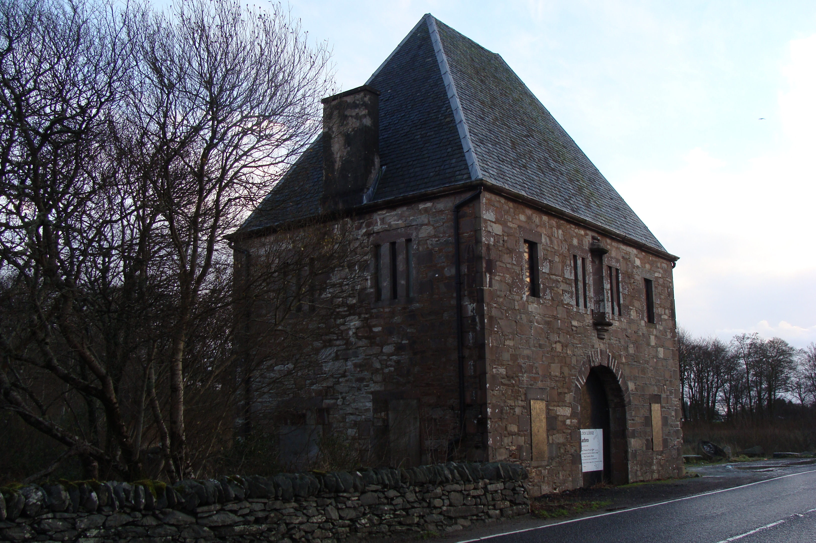
Fig 1. View from north west. Malcolm Sinclair.
The lodge is currently vacant and unused and has been for many years. It has been the subject to both neglect and vandalism.

Condition Summary
The structure of the roof has been replaced. It has been re-slated in Scots slates with zinc hips but without the dormers or clock faces that give the building its name. The dormers and clockfaces are stored within the building.
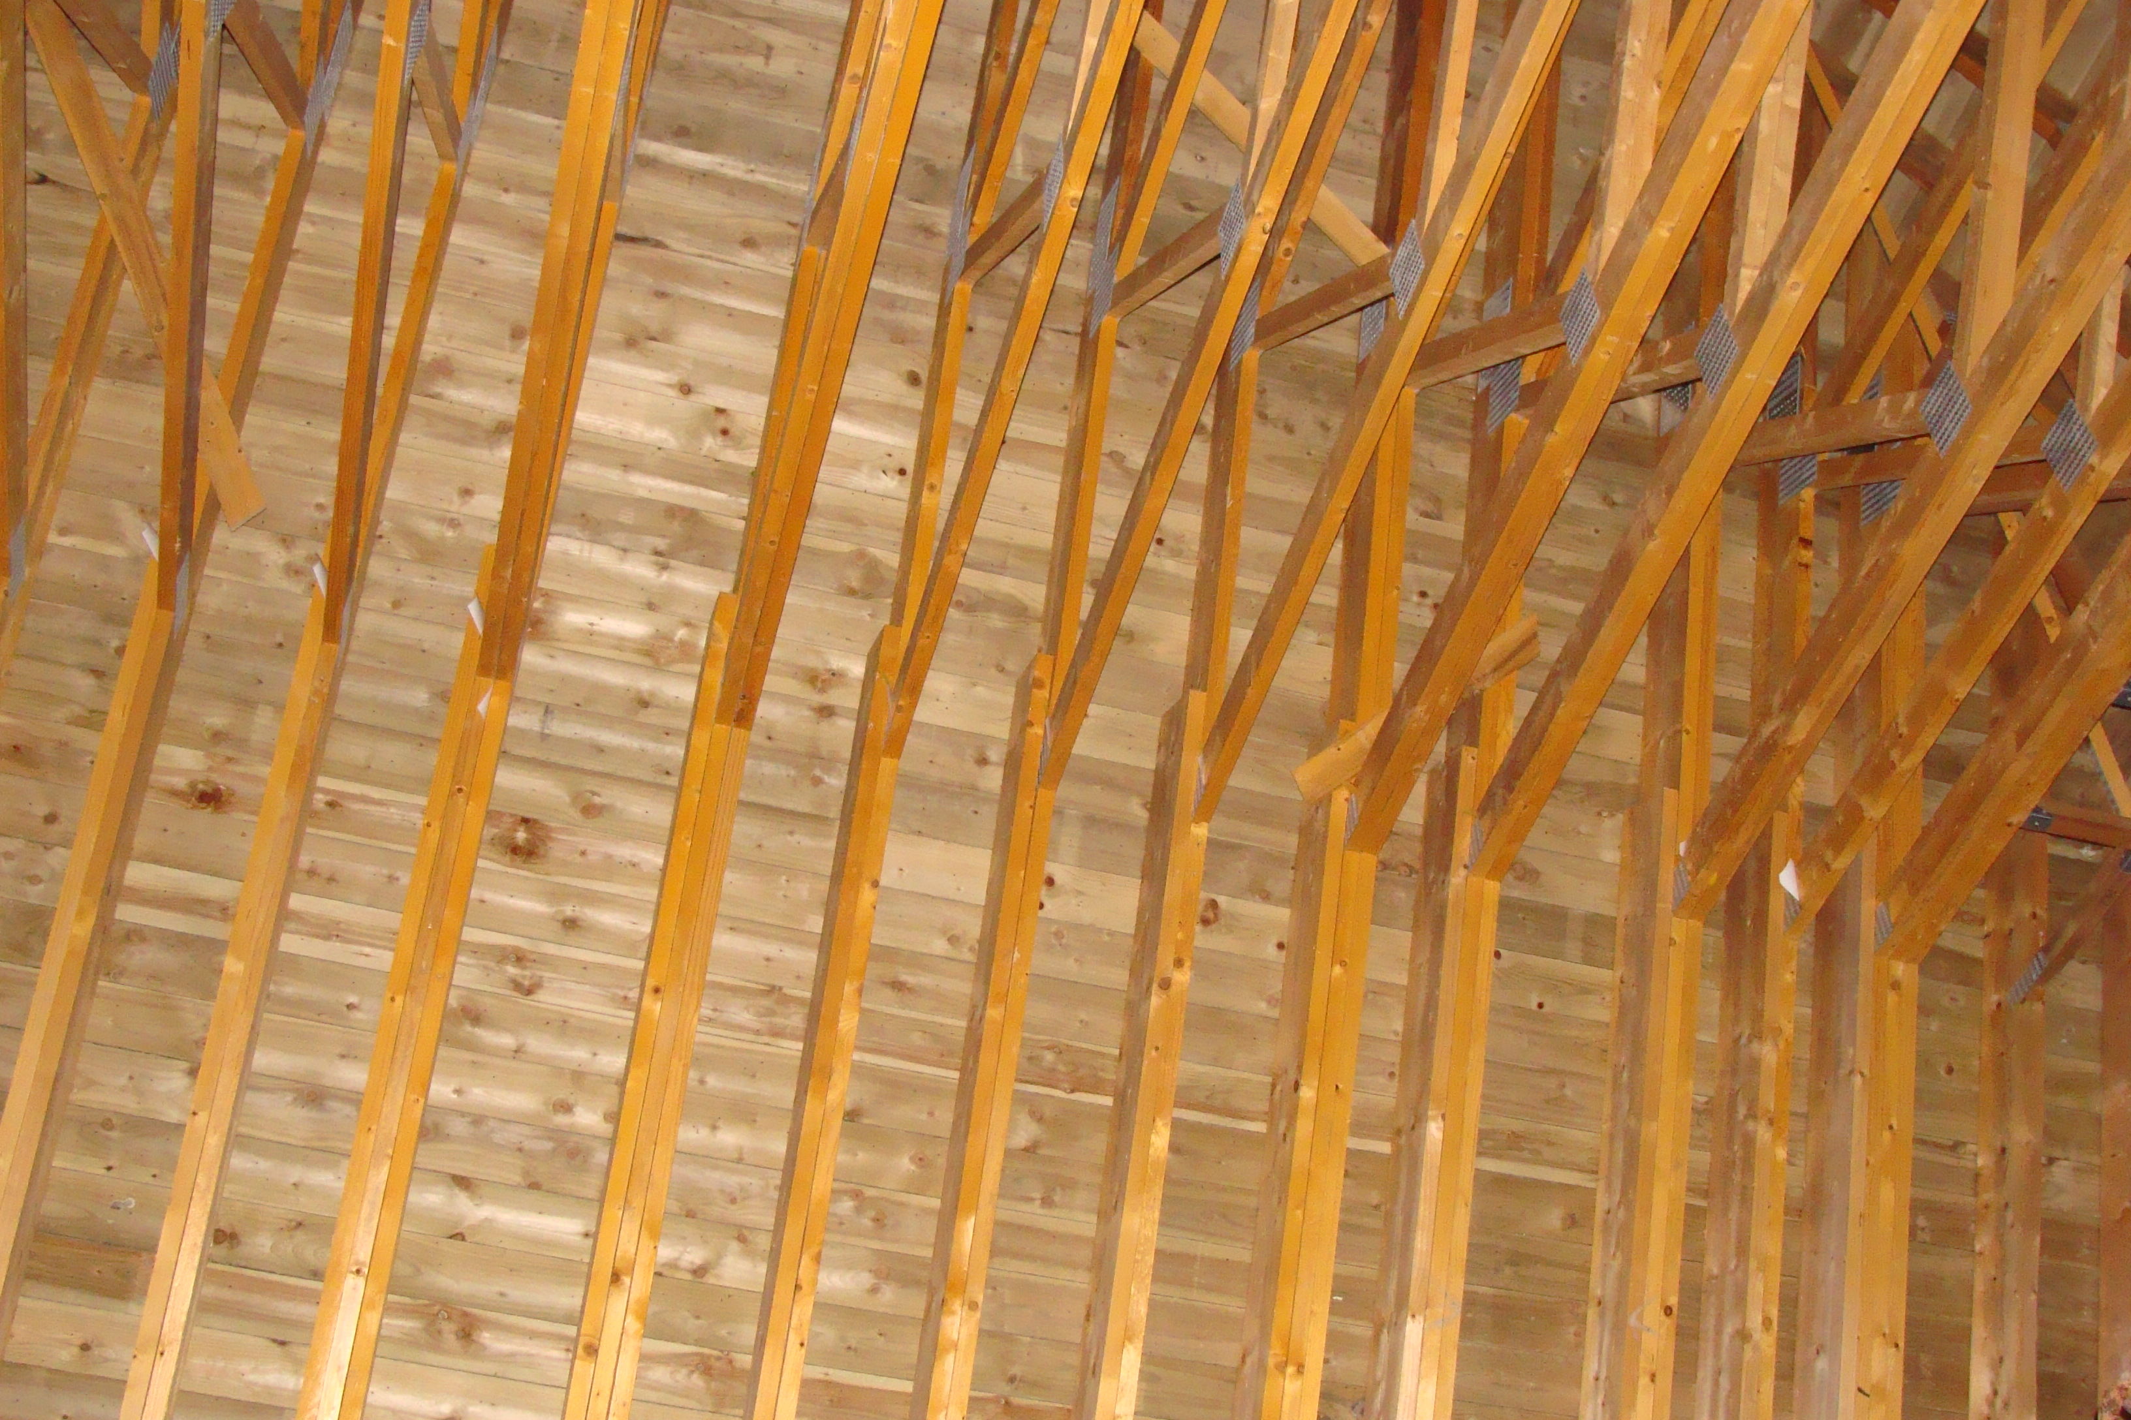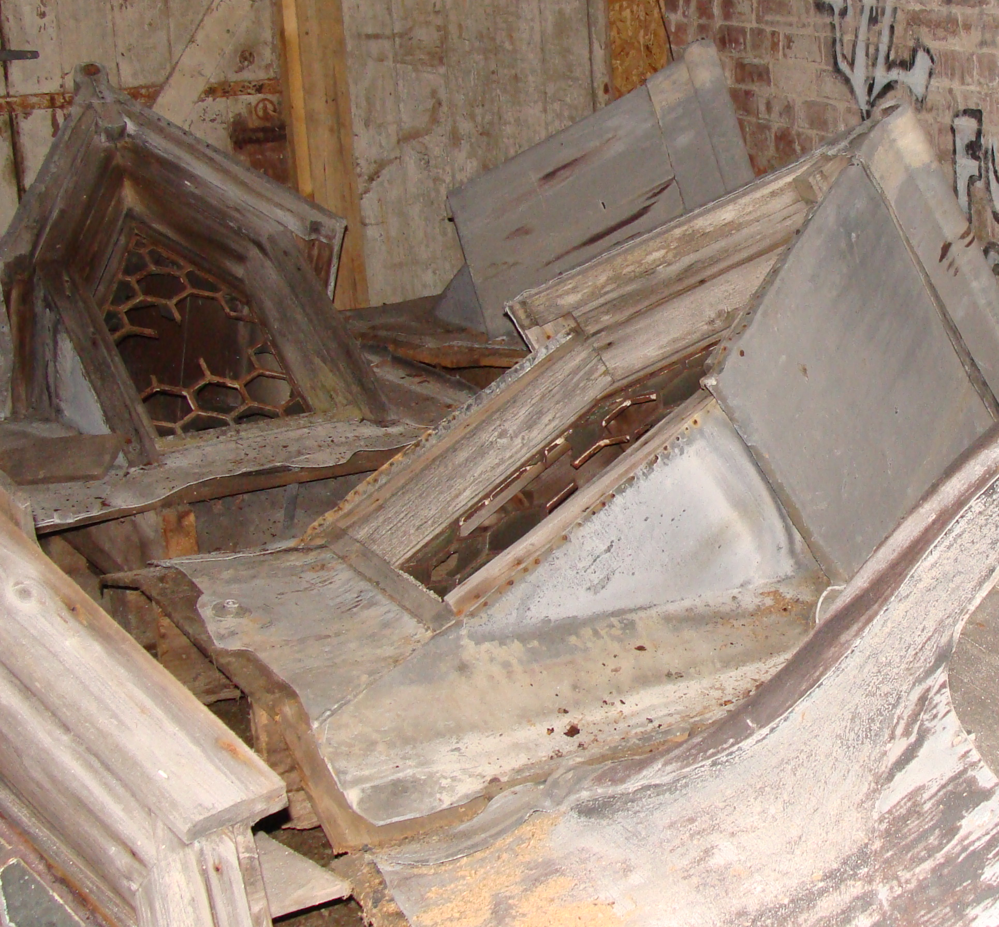
Fig 2. New roof structure and dormers stored within the building. Malcolm Sinclair.
Internally the lodge is largely a shell. The ground floor is separated into small cellular rooms to the north and south of the central carriageway. Rising damp is evident within most ground floor walls. The original stone stairs to the first floor appear to have been encased on top by modern concrete. These stairs lead up to a large open space of the first floor. Ceilings and wall plaster have been removed. The first floor is constructed of jack-arch brick vaulting. The timber floor on top of this structure had become severely decayed and has been removed. All windows have lost their glazing.
The external appearance of the lodge presents a robust masonry structure. The external sandstone walls appear to be in reasonable condition but areas of defective and washed-out pointing are evident. There has been some stone erosion and deterioration. Structural movement was noted within the exterior stone walling.
Prior to the roof replacement, the main roof comprising timber roof structure, slate covering and dormer clock faces and gabled glazed windows were all found to be in very poor and deteriorated condition, requiring extensive repair and restoration. The extent of decay had been causing saturation in the masonry for many years.
Most timber windows will require either comprehensive repair or full replacement, as will the two carriage entrance double doors.
The building is a fairly robust building and the masonry has coped with its periods of poor care and management.
The adjacent A83 is now higher than the existing ground floor levels of the lodge, presenting a drainage condition which will be difficult to resolve.

Limitations
This report is based on a visual, non-disruptive inspections of the building. No opening up was done; in any visual inspection it is often difficult to assess the full extent of a fault and it is always possible that an opinion may have to be revised when work is opened up.
No advice is given or implied regarding the presence or otherwise of any asbestos within the property. Should any areas be suspected, the client is advised to follow Health and Safety Executive guidelines.

HISTORY AND SIGNIFICANCE

History of the Property
The Clock Lodge was built in the 1830s for Sir John Powlett Orde of Kilmory Castle. The castle had been extended to approximately its current form and the Home Farm built at approximately the same time. Orde had his own private causeway across Loch Gilp, allowing him to drive his carriage through the Clock Lodge and across the loch to Ardrishaig. The name derives from the clocks that were situated high up on the roof of the building.
Orde was one of the oddest local figures in Mid Argyll in Victorian times. He often came into conflict with local people, for example his “war” with fishermen who used Kilmory Quay. There was even a case of assault brought against him in 1832. The story of the lodge is supposedly tied up with his bad temper. According to folklore, he took his whip to a child while driving his carriage through Lochgilphead. When local people threw stones in retaliation, he vowed never to pass through the town again. For this reason, he built the Clock Lodge and the causeway, thus by-passing Lochgilphead. There are elements of truth in this story; Orde was charged with assault and was tried for lassoing a child with his whip and dragging him behind his carriage. His acquittal raised questions in Parliament about the justice of the verdict.
Records show that this incident occurred in Ardrishaig many years after the construction of the Clock Lodge and causeway. It is possible that the construction of the lodge and causeway are linked to Queen Victoria’s visit to the Crinan Canal in 1840. Orde was determined that the Queen should visit him at Kilmory and the causeway and lodge entrance to his grounds would allow Her Majesty to avoid the tedium of the inevitable civic reception had she passed through Lochgilphead. Furthermore, crossing the loch at the appropriate state of the tide would have given the impression that the monarch was rising upon the water. Victoria never visited Kilmory, despite one of the rooms there being named after her.
Orde seems to have been almost obsessed with driving at speed. He devised gates for the Clock Lodge that would open just as the carriage reached them and the “front door” of Kilmory Castle was a large gate that admitted carriages to a road passing through the castle complex.
The purpose of the upper floor of the Clock Lodge is not known. Its floor was made of iron beams supporting brick arches capable of supporting a considerable weight. It may have held machinery of some kind or possibly been a workshop. Alternatively, it could have been some kind of industrial training centre for the children of his estate workers. As recently as the 1940s – ‘50s, the upper floor was fitted out as a library.

20th Century History
Local people recall tales of dances being held there three or four generations ago. Despite the doubts as to its uses down the years, the building was solidly built and has survived decades of neglect. Murdo MacDonald, the County Archivist, thinks that the clock may have been designed to ensure that the estate workers arrived promptly at 6.30 a.m. to receive their instructions for the day. It is likely that the ground floor would have been used by estate workers and possibly housed a lodge keeper who would have opened the doors when requested or when Sir John approached.
The lodge was occupied until the 1960s, when it was owned by the Forestry Commission and occupied by Kenneth McSwan until 1964. At this time, the Council had plans for new offices in the adjacent field where Ross Crescent now stands and the lodge passed into Council ownership. After a period of use as a joiners’ workshop and then a store by local company Donald MacDonald, it became vacant in the 1980s.

The Architect
No plans for the Clock Lodge survive, and the architect is unknown. However, there is some circumstantial evidence to suggest the involvement of Joseph Gordon Davis, a London builder.
Davis had been introduced to work in the locality by Sir John Powlett Orde who had worked with him in his remodelling and enlargement of the mansion at Kilmory. The remodelling of the home farm and stables can also be ascribed to Davis. Davis also undertook minor design work for the Duke of Argyll and some more substantial work, including Kilmartin Church, for the Malcolms of Poltalloch. His last known work in Mid Argyll was a large hotel in Ardrishaig (now The Grey Gull) in 1842, but it is unclear if he was architect or builder in this case. In his other major Mid Argyll work he was clearly involved in design.
Davis’s practice as an architect seems to have been limited to a small circle of clients in Mid Argyll. It has been speculated that his main quality was his ability to interpret Orde’s wishes. It may even be that Orde played a design role at Kilmory and even at Kilmartin Church which Davis interpreted, and it is possible that Davis and possibly Orde shared a role in a further Mid Argyll mansion, in additions to Craignish Castle carried out in the 1830s in an English Manorial style which has much in common stylistically with Kilmory Castle. This is speculation, but it is certainly clear that when Orde’s remodelling at Kilmory began, Davis was in his early 20s, and that his architectural career virtually ended on his (for all we know, permanent) return to London in the 1840s. When he died, aged 87, in 1893 he was a well-off retired London builder whose only “celebrated” architectural work in his own city was the addition to his own house: Howard Colvin credits Davis with having “vulgarly extended” his house in the 1880s.
There is no stylistic link between the English Revival style employed by Davis at Kilmory and elsewhere in Mid Argyll and the continental historical style of the Clock Lodge with its tall French or Germanic roof but there are similarities of detailing. The Clock Lodge arched entrances have strong similarity to those over the service route at the rear of Kilmory Castle and the timber mocked-up “portcullis” on the clock lodge is very similar to those used at Kilmory Castle and on the Kilmory Home Farm. Unusual metal window frames which emulate leaded glass were employed at the Clock Lodge, but also at Kilmory Castle and on Poltalloch Estate workers housing c1850. The clocks on the roof above the Clock Lodge are reported to have been similar to that formerly found on the arch to the rear main entrance at Kilmory Castle. While these factors do not prove the presence of the same architect, they do not disprove it either.

Significance
The Clock Lodge is a good example of a large scale entrance lodge to the grounds of a mansion, built for a mid-19th century landowner, in this case for Sir John Orde of Kilmory. Orde, though technically “new money” and an incomer in the context of the West Highlands, had married into the local family of the Campbells of Kilmory in 1828. In common with many old established Argyll families such as the Malcolms of Poltalloch, Orde appears to have had income from estates in Jamaica. The Ordes also had a London residence.
The Clock Lodge forms a significant and highly visible part of a building program which began almost from the moment Sir john Powlett Orde took possession. Kilmory was the first of a series of large private built in Mid Argyll in the 19th century. Kilmory was the first in its locality of very major country houses in romantic historicist styles. Such residences combined very extensive accommodation with asymmetric massing and layout, and placed a strong emphasis on “convenient” servicing. After Kilmory (1828 onwards) came Stonefield (originally Barmore) in the 1830s, and Minard and Poltalloch in the 1840s and ‘50s.
Orde’s enthusiasm for his building projects comes through the pages of the New Statistical Account: the chapter on Glassary Parish, by the Rev. Dugald Campbell, includes description of Kilmory Castle written by Orde himself which occupies a page, a virtually unprecedented coverage for a mansion house. There also appears to be clear evidence from Orde’s contributions to the New Statistical Account that his role in the internal fit-out and furnishing of Kilmory Castle would have been considerable, since he specifically mentions acquiring major elements such as furniture from a Portuguese palace and wallpaper “manufactured expressly for us” in China. According to local tradition, the main stair balustrade is supposed to have been purchased in Rome, corroborated in part by a separate tale which describes the Baronet in his first years at Kilmory setting out to Rome [Wife: “Where do we drive to today, Sir John?”. Sir John: “Rome, Ma’am”].
There is every reason to believe that as a client commissioning architectural work, Orde was strong willed and with personal interests which left their imprint on the design of work for him. His interest in racing carriages led to the development of slip-roads and roundabouts in the Kilmory policy roads. His designs for field gates are known to have been awarded prizes at Highland and agricultural shows. He is even attributed by an oral tradition to have had a specific interest in carriage gateways spring to open automatically as an approaching carriage crossed a metal plate. This is also documented to some extent by anecdotal evidence in Recollections of a Scottish Novelist by LB Walford. A set of garden gates survives at Kilmory, showing a pulley system intended to assist easy opening. At Kilmory Castle, the approaching visitors’ carriage was intended to effectively enter the house through the apparent “front door” which have access to a tunnel within which the visitors alighted and gained admittance to a tiled inner hall. Given the overall emphasis on gates and gateways, it is not unrealistic to assume that these were dictated by the client’s interest. Within this context, the provision of a highly unusual lodge or gatehouse, pierced by a pend sealed by sliding doors at either end, and directly facing and serving an innovative if eccentric causeway, seems to specifically relate to several private concerns of the client.

Detailed inspection of the fabric
Roofs and Rainwater Goods

West Pitch
The pitch is slated with Scots slates. The ridges and hips are zinc flashings fitted with clips from above with nails through the flashings. The entire roof was re-slated over a new roof structure within the last ten years. Although this work prevented water from getting into the building on this pitch, and although it “solved” the historic problem of the decaying roof structure by the radical decision to replace it with a new roof structure, the clock and three dormers which are an essential part of Kilmory Clock Lodge were not reinstated to this pitch.
A gutter was fitted to the base of the pitch which distributes to pipes on the north and south elevations close to the south west and north west corners, through a swan’s neck pipe.
The slating is in good condition but needs periodic overhauling to ensure that all slipped, cracked and missing slates are rectified and will not cause minor leaks within the building.
The zinc capping to ridges and hips is common practice but not of sufficient standard for historic buildings repair. These ridges and hips should be replaced with a lead detail to current trade standards.
At ridge level any evidence for a detail at the ridge, such as brattishing, will now have been lost due to the replacement of the roof structure, however, brattishing should be considered since it is consistent with this type of architectural detail.
The clock and dormers are currently stored within the building. They are in fair condition but will need overhauling in a workshop before reinstatement. All dormers should be reinstated complete with leaded glazing to match original pattern.
The cornice and gutter at the base of the pitch can be retained as repaired in the previous work, but the pipe spouts on brackets at the corners should be reinstated. They would not function as the main form of water distribution but they made a significant contribution to the character of the building. They could form an overflow to some extent but the link through swan’s neck pipes to pipes on the north and south walls should be retained.

South Pitch
The slating and roof structure have been renewed and are in fair condition. The clock face is stored within the building and needs substantial overhaul in a workshop before being reinstated to its original position on the roof.
The flashings around the base of the chimney could not be inspected in detail. It seems probable that they are not finished to current trade standards required for grant-eligible work and will have to be substantially overhauled or renewed to meet these standards.
The hips would be replaced with lead in a grant-aided scheme in order to be returned to the original material and detail. The detail at the cornice would be retained but might need some inspection and overhauling.

East Pitch
The slating and roof structure are in good condition having been renewed recently. The slating requires an overhaul replacing slipped, cracked and missing slates as necessary. The clock dormer is stored within the building and should be reinstated to this pitch.
There were three dormers below the clock on this pitch. Only two survive. These should be reinstated. The missing dormer should be made to match the existing examples exactly and reinstated so that there are three dormers across this pitch. All dormers should be reinstated complete with leaded glazing to match original pattern.

North Pitch
The slating and roof structure have been renewed and are in fair condition. The clock face is stored within the building and needs substantial overhaul in a workshop before being reinstated to its original position on the roof.
The flashings around the base of the chimney could not be inspected in detail. It seems probable that they are not finished to current trade standards required for grant-eligible work and will have to be substantially overhauled or renewed to meet these standards.
The hips would be replaced with lead in a grant-aided scheme in order to be returned to the original material and detail. The detail at the cornice would be retained but might need some inspection and overhauling.
External walls, windows and doors

North Chimney
This chimney is in poor condition, has been previously partly rendered and rebuilt to a poor standard. The chimney masonry is saturated.
The most appropriate action for this chimney would be to take down the entire chimney and to rebuild. Allow for re-using 50% of existing stone. The chimney should be rebuilt according to a detailed assessment of existing evidence for chimneys on both north and south pitches.
The chimney should include damp proof membranes at the level of the flashings at the junction of chimney and roof, and under the cope at the head of the chimney. The chimney was probably intended to have two flues and so should have two ceramic cans.

South Chimney
The south chimney is intact but the upper courses could not be inspected in detail. The masonry is saturated and will be a way of conducting water into the building. The upper part of the chimney should be taken down, a DPM built into the chimney above the level of the flashings with the roof. The masonry should be rebuilt using new stone where the existing stone is either missing or damaged. A DPM should be included underneath the cope.
The existing ceramic cans should be bedded onto the rebuilt cope. The current cans look to be in the wrong position and should be repositioned over the original flue positions. The current ceramic cans look to be salvaged from another building and not original and should be replaced by matching cans.

West Wall
All walls are rubble masonry which would originally have been built and pointed in lime mortar but have been repointed in cement.
Recent repairs have been made in lime mortar to some of the stones around the arch.

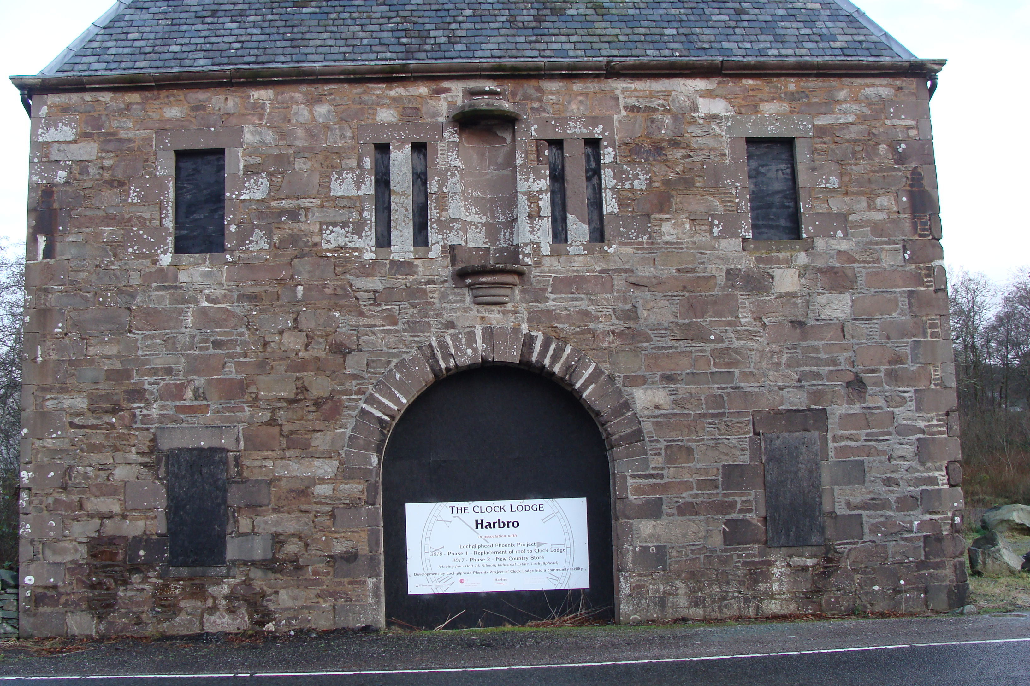
Fig 3. West wall. Malcolm Sinclair.
The rubble stone is local metamorphic rock. Dressings are softer, red sandstone. Buildings of this construction frequently have problems of water running through to the core of the wall and interior. Water cannot evaporate out through this type of stone. This is made worse by cement pointing because it means that water cannot evaporate out through the joints either. The cement will crack allowing water into the wall which cannot evaporate to the outside. The best type of repair for this wall would be almost full repointing. The exception would be the area of apparently original pointing in the top 300-400mm where it has been protected from decay underneath the cornice at the head of the wall.
There are some areas of damp masonry, particularly near ground level. The lime mortar pointing would help this wall to dry out but drainage is also needed across the base of the wall. It is lower than the road surface and so water tends to flow towards the base of the wall and needs to be conducted away.
The masonry generally is in fair condition. There are cracks through the masonry above the central arch and between the upper and lower windows to the north. During repointing these cracks would be carefully packed with lime mortar and small stones to consolidate the crack before repointing up to the surface wall plane.
One stone at the ground floor south window is badly damaged and should be indented using new natural sandstone to match the existing in colour and weathering characteristics.
The upper and lower windows to the north and south are missing their central mullion. Reinstatement of this mullion would mean that the windows match the other mullions on the building. The seating for this mullion is visible on the sills of each window.
The slit windows originally had two over two sash and case windows in painted timber. Windows to this design should be reinstated according to evidence for windows on the building.
The sliding door should be overhauled to full working order including the mechanism and the ironmongery. The ironwork at the head of the arch should also be repaired and repainted.

South Wall
The masonry is similar to the west wall. Substantial repointing is required at areas of masonry which are damaged or have been repointed using cement mortar. There are areas which appear to show salts, efflorescence, particularly at the head of the wall above the lintels at the upper level. These salts might indicate drying following the replacement of the roof. Salts should be brushed away from the masonry surface, not washed, as this would simply push the salts back into the stone.
Some areas of the masonry, generally at first floor towards the corners, are in better condition but full repointing of cement mortar might be appropriate on detailed inspection once the building is scaffolded.
A vertical area of damaged masonry between the windows, slightly to the east of the vertical centre line, needs more detailed consolidation and pointing to repair eroded joints. This is probably associated with a flue.
Fig 4. South wall. Malcolm Sinclair.
Only fragments of joinery remain in the upper windows. These should be carefully taken down and used as the basis for window reinstatement. Window reinstatement would be carried out in painted timber. Existing timber to be analysed to determine original colours.

East Wall
The masonry is similar to the other walls. It requires almost 100% repointing because the cement mortar damages the existing stones around the openings.
In some places cement has been smeared over stones. Cement over stones should be removed and the stone examined for possible indenting. There is one stone in the cornice which has been crudely covered with cement. This cement should be removed and the stone considered for indenting.
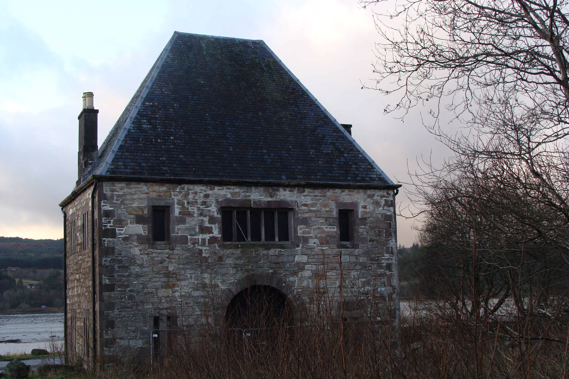
Fig 5. East wall. Malcolm Sinclair.
During the repairs associated with the re-roofing, there has been some repointing, particularly at first floor level. This repointing has been carried out using lime mortar but the quality of the work is poor and the work should be carried out again. The pointing has been allowed to dry to a white colour and the joints appear to be insufficiently raked out before the pointing mortar was carried applied.
To the south part of the main doorway there is damage to the lowest two voussoir stones which should be carefully examined for repair.
There are some areas, such as between the central and south window on the upper floor and to the north of the north window on the ground floor, where more intensive raking out, consolidation of joints, and repointing is required.
The stone mullions should be restored to the upper windows to match the lower windows. To the central upper window the hexagonal leading should be reinstated to the window mullions. The other four windows should have sash and case windows restored to match evidence elsewhere.
The sliding door and mechanism could not be inspected.

North Wall
The masonry is similar in construction and condition to the other walls. Substantial repointing is required. There is a crack between the sill of the upper west window and the lintel of the lower west window. This should be raked out, consolidated and packed before repointing. Vegetation should be cleared from the base of the wall.
Windows should be reinstated as two over two sash windows to the slip windows according to evidence elsewhere on the building.

Interior

Internal Structure
The overall stability of the building relies on the thick external stone walls. The internal brick walls are believed to be vertically loadbearing but not providing any lateral restraint to the outside walls. The roof and first floor act as a diaphragm transferring horizontal loads into the laterally stiff external walls whilst providing restraint to the wall at the first floor level and at the eaves. The lateral integrity may have been compromised due to previous damage to the roof. The first floor deflects noted, however, should not compromise the lateral rigidity of the building in its current form.
Vertical stability is provided through the timber roof trusses at roof level and brick arches on steel beams at first floor level which transfers the load to the loadbearing internal and external walls below and down to the underlying bearing strata. The building foundations were not exposed during the survey and are therefore unknown at this stage.

Roof Structure
In the interior the roof structure has been changed entirely. It has been repaired so that the roof no longer leaks but this has been by replacement to a different design. The interior is now stripped out to bare walls although the original detail around windows etc has been recorded. In general the condition is improving due to drying following the replacement of the roof. Although it means that historic detail has been lost, the stripped out inside walls do allow evaporation which is an advantage at this stage as the building is drying.

Upper Room – internal wall faces
The drying of the building also makes it easy to understand where the building is failing to dry due to a leak. This is generally associated with the chimneys in the main upper room. The pattern of water and staining associated with the chimneys tends to increase and decrease with seasons and weather. This shows that this is an active leak with water soaking in from the chimneys. Proposals for remedial action including insertion of DPMs within the chimneys have been noted earlier in this report.
All internal lintels appear to be of green slate construction and are currently showing no signs of structural distress.
Some of the windows are built with infills of green slate. The slate could be removed from the infilled windows without compromising the significance of the building.

Floor Structure
The first floor timber flooring and deafening layer was supported by one brick thick arches spanning between steel beams onto loadbearing walls below.
The brick arches appear to be in reasonable condition. The steel support beams are rusted by show no signs of structural distress or material loss.
The timber floor finish, structure and deafening have been removed.

Ground floor
The floor level is noted as being circa 500mm lower than the road level at the west entrance. There is a 1.2m wide verge sloping from the road towards the west entrance. The ground floor comprises a concrete slab finish with no current signs of distress in the north and south rooms only. The centre section consists of soil with no floor construction.
All internal lintels in the external walls appear to be of green slate construction and are currently showing no signs of structural distress. The slate could be removed from the infilled windows without compromising the building.
All internal lintels on cross walls are of vertical arched brick construction and generally do not exhibit signs of structural distress, however, there is a missing centre brick over door opening to the south east room. A replacement brick should be fitted back in.

Stairs
The stairs are noted as being of stone construction on steel runners and appear to be in reasonable condition. The steel shows signs of rusting but no signs of structural distress or material loss.

Internal Walls
The internal walls from ground to the underside of first floor level are loadbearing brick construction and appear to be in reasonable condition throughout. They show signs of moisture ingress. This might be associated with the extensive use of cement mortar on the exterior.

Internal Timber Mezzanine
There is an internal timber mezzanine structure within north rooms. The structure appears to be in reasonably good condition, however, the timber supports are embedded in the walls and it is unknown what bearing length the joists have.

Sliding Timber Doors
The west and east sliding timber doors have some decay with the sliding mechanism seized.

Drainage
Ground was noted as being very marshy around the building and there was no evidence of working drainage.
Drainage should be introduced to prevent water flooding the ground floor from the west at the front entrance. The land drainage surrounding the building should be improved.

REcommendations

Repairs Schedule NB See additional attachment for estimated costs from Quantity Surveyor.

 |  |  | Urgent | Phase II
4.1.1 | South Elevation
Rebuild chimney. Allow for ashlar courses plus cope course projecting about 25mm. Reset existing buff ceramic cans. |  |  |  | X
Fix curved headed dormer to upper part of pitch above chimney. Allow for flashings around dormer. Assume dormer constructed in timber with lead cover. Salvage slates for re-use in area of dormer. |  |  |  | X
New lead flashing behind chimney. Insert sacrificial flashings at run-off point from lower edge of slate. |  |  | X
Refix brackets and lead pipes to shed water away from building. Even if these are not used, they are part of the decorative scheme of the original and should be reinstated. |  |  |  | X
Repoint open joints in cornice. Nine joints in total. |  |  | X
Rake out and repoint joints in lime mortar as indicated on drawing. This work to include removal of white pointing. |  |  | X
Retain rainwater pipes which have been fitted but fit new hoppers at head to allow reinstatement of projecting pipes at corner. |  |  |  | X
Upper windows. Remove slate infill from three openings in each of two windows. Reinstate with timber frames which give four equal panes with astragals in line with horizontal joints. |  |  | X
Assume same as first floor windows for ground floor windows. |  |  | X
Add 50% of pointing cost as contingency. |  |  | X
Repoint all joints in chimney to masonry section below rendered area. |  |  |  | X
4.1.2 | East Elevation
Ridge. Reinstate brattishing in wrought iron with straps tied down into ridge. |  |  |  | X
Reinstate clock face and three dormers. These had hexagon leaded glazing. Lead flashings into slating. All other slating is in good condition. Ridge detail has been fitted incorrectly, apparently with lead and then with holding down straps from above using incorrect detail. Include for clock mechanism.  Allow for carefully placing existing clock face and dormers into storage as part of phase 2 works – location to be agreed. |  |  |  | X
Make stone indent at cement covered stone in cornice. Lift lead cornice gutter and refix on completion. |  |  | X
Repoint as shown on drawings. |  |  | X
Reinstate dormer windows to upper level, with hexagonal glazing as shown on drawings. |  |  | X
Repoint at deep pockets. Grout to masonry around lower two voussoirs on south side of arch. |  |  | X
At lower windows, remove boards, two openings each with central stone mullion, treat as south elevation. |  |  | X
4.1.3 | North Elevation
Reinstate clock dormer as for south elevation. |  |  |  | X
Take down and rebuild entire chimney including base course which is cement. New stone cornice. Fit 2no new buff ceramic cans. |  |  |  | X
Repointing as indicated. |  |  | X
Pipes and corner pipes including brackets as noted for south elevation. |  |  |  | X
Remove slate infill from upper windows and reinstate as for south elevation. |  |  | X
Remove boards from lower windows and reinstate as for south elevation. |  |  | X
4.1.4 | West Elevation
Ridge brattishing as east elevation. |  |  |  | X
Repoint all open joints in cornice. Eleven in total. |  |  | X
Repoint and make indents as noted on drawing. Allow further 50% of cost as provisional sum for masonry repairs. |  |  | X
Reinstate central mullion stones to ground and upper floor openings. |  |  | X
Investigate electrical supply drilled through to base of niche, a possible position for displaying art objects. |  |  |  | X
Reinstate windows, as noted for other elevations. |  |  | X
Reinstate or repair sliding door |  |  | X
Remove timber from upper north rybat stone to south ground floor window. |  |  | X

NOTE - See additional attachment for estimated costs from Quantity Surveyor.
AND the referenced drawings are pages 53 to 60 (appendix C) in the 2017 Feasibility study attached

